Safeguarding Children GP / Level 3 Training
(Derbyshire County)
2019:

This training is aimed at GP’s, Specialist Nurses and Practice Nurses who have any contact with children, young people and/or parents/carers – require 3 hours of training every year or 9 hours over a 3 year period.
Date: | Time: | Venue:
Wednesday 10 April | 2:00 – 5:00pm | Panthers Rugby Club, 2012 Dunston Road, Chesterfield,  S41 9BF
(N.B: Training time has been extended following the newly published intercollegiate document).
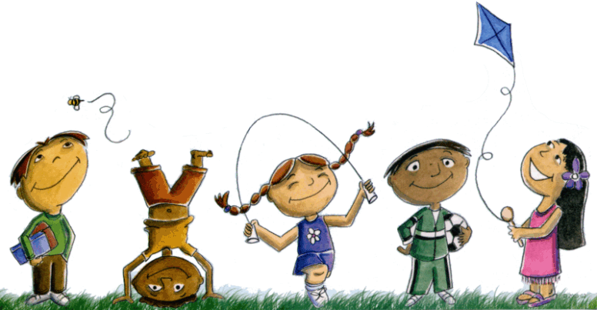

Please contact: Cat McMenamin (Secretary, Derbyshire CCGs) by e-mail: cmcmenamin@nhs.net or Tel: 01332 868878 to book a place.

