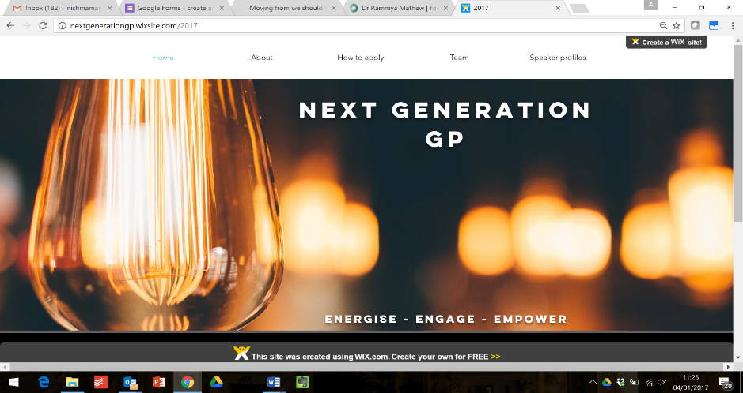
East Midlands

WHAT IS NEXT GENERATION GP?

‘Next Generation GP’ is a programme for emerging leaders in general practice designed by, and for, a group of early-career GPs and trainees.
Our aim is to inspire GP trainees and newly qualified GPs to be informed leaders as well as excellent clinicians, with the insight and connections they need to change and improve the system in which we work. We are excited to announce that applications are now open for the second cohort for East Midlands Next Generation GPs.

Why?

In the face of unprecedented pressures, the landscape of the NHS is changing rapidly, with the centre of gravity rapidly shifting towards primary care. This represents an exciting opportunity for GPs, with their unique overview across the system, to be involved in improving frontline services for our patients.
But with the largest curriculum and the shortest amount of time to learn it all, many of us are starting out without a clear understanding of the system we’ll be working in, the changes being planned around us, or the tools to lead change effectively.
Our belief that the success of any sustainable change in the NHS will be based on the strength of the network of people behind it was the driving force behind the creation of this programme.
Our aim is for participants to feel:
- ENERGISED: through access to the stories, perspectives and expertise of inspiring leaders at the forefront of primary care;
- ENGAGED: through a supportive network of like-minded local trainees and early-career GPs;
- EMPOWERED: through a series of workshops that will begin to increase your ability to shape care within and beyond your organisation.

WHAT WOULD i GAIN?

REGULAR Events
Participants will benefit from the unique opportunity to meet, engage with, and ask questions of some of the foremost leaders in the NHS.
Each evening is divided into two parts. The first is a themed workshop, talk or facilitated group work session addressing a specific leadership challenge. Complementing each of these will be an interview with an inspiring national leader, with time for the audience to put their own questions to our guests.
These events will also be a fantastic opportunity to build relationships with like-minded GPs and trainees in your area. Each event will be worth 2 CPD points.
The core programme (see below) consists of a series of regular events:
Date | Workshop/Lecture | Interview
13 August 2019 | Dr Robert Varnarm  National Director of Professional Leadership for Improvement  NHS England and NHS Improvement | Prof Nick Harding OBE  Founder of the Modality Partnership/Senior Clinical Advisor to the Integrated Care System programme
12 September 2019 | Mr David Ainsworth  Locality Director  Mid Notts CCG | Dr Duncan Gooch  GP, Executive Partner and Chair  Derbyshire GP Alliance
3 October 2019 | Strengths Finder Coaching Session  Hannah Miller  Gallup Accredited Strengths Coach
21 November 2019 | Dr Claire Marie Thomas  GP, Past President Vasco Da Gama Movement, Director Empathy LLP | Dr Carolyn Wilkins OBE  Chief Executive Oldham Council and Accountable Officer NHS Oldham CCG
30 January 2020 | Dr Nikita Kanani MBE  GP, Acting Primary Care Medical Director  NHS England and NHS Improvement | Prof Simon Gregory DL  GP, Deputy Medical Director, Primary and Integrated Care, Health Education England

A Virtual network

We will establish a virtual network on social media for the group to facilitate discussion between events, pool resources that emerge from the workshops, and share local opportunities. There will also be opportunities to connect with Next Generation GP participants from our other programmes across the country and access other exciting leadership opportunities.

WHAT NEXT?

- We have a limited number of fully-funded places to offer on the programme for early-career GPs and GP trainees (preferably within the first 5-7 years post CCT).
- The events will be held on weekday evenings from 6.30pm-9.15pm.
- Please be aware that whilst there is no programme cost for participants, each place represents a significant investment. We cannot reimburse travel costs, but some previous applicants have been able to use their study leave to attend.
- To ensure maximum benefit from the programme, participants will need to commit to attending at least 4 out of the 5 sessions (dates shown above) and participate in an evaluation process.
- The dates and venues are as follows:
13 August 2019 | Holiday Inn, South Normanton, M1 Jct 28, DE55 2EH
12 September 2019 | Holiday Inn, South Normanton, M1 Jct 28, DE55 2EH
3 October 2019 | Double Tree by Hilton, Nottingham Gateway, Nuthall Road, NG8 6AZ
21 November 2019 | Double Tree by Hilton, Nottingham Gateway, Nuthall Road, NG8 6AZ
30 January 2020 | Double Tree by Hilton, Nottingham Gateway, Nuthall Road, NG8 6AZ

Applicants are invited to submit a brief expression of interest outlining their motivation for applying:

- The person specification can be found at: http://bit.ly/nextgenspec
- The application form: https://forms.gle/feXVUfaXPAJ13d647

Applications for Next Generation GP are open from 1 July and close on 20 July. We will aim to inform all applicants of the outcome one week after the closing deadline.
Please visit our website for more information but if you have any questions, please email: nextgenerationgp@gmail.com
