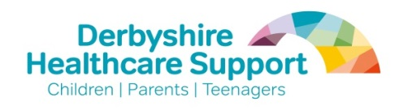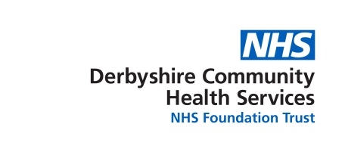
DCHS Infant Feeding Team
Gosforth Valley Medical Centre,
Gorsey Brigg,
Dronfield,
S18 8UE

Dear GP colleagues,
.
DCHS are due to go for Baby Friendly Reaccreditation in July 2019. Baby Friendly accreditation is a systematic, evidence based approach to providing care and support for families with young babies and is recommended in the NHS long term plan.
As part of our accreditation process, DCHS would like to offer free CPD learning to GPs within Derbyshire. The Baby Friendly online training in infant feeding has been funded by DCHS until 31/7/19.

The course is split into modules, allowing learners to pause and resume where they left off.
Learning outcomes are;
- How to treat common breast conditions (e.g. mastitis, thrush);
- How to access a reliable reference source for prescribing drugs for breastfeeding mothers;
- How to refer mothers to the most appropriate professional for breastfeeding help and support (particularly when a baby has faltering growth).
Upon completion of the training, GPs can print off a certificate for their portfolio.

The course can be accessed via https://babyfriendly.litmos.com/self-signup/ using the code “17derbyshire”. This code is only valid until 31/7/19. Further instructions on accessing this are attached.

DCHS employ a number of staff who can help GPs in their support of infant feeding.

To refer families to an infant feeding specialist (a nurse or midwife who has trained as a lactation consultant and who is able to assess and manage complex feeding issues) please email a referral to Breastfeeding-SpecialistReferrals@nhs.net

If parents would like to know about their local breastfeeding groups and volunteer breastfeeding supporters they can find the details via our website: www.derbyshirehealthyfamily.org.uk.

For more information on infant feeding specifically written by GPs for GPs please access https://www.gpifn.org.uk/

Please contact the infant feeding specialists if you would like more information on the email address above.

Best wishes,

The DCHS Infant Feeding Team

