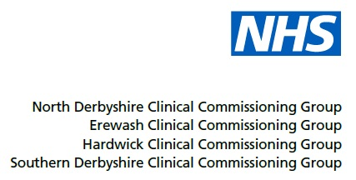

1st Floor North
Cardinal Square
10 Nottingham Road
Derby
DE1 3QT

www.southernderbyshireccg.nhs.uk
25 September 2018

Dear Practice Manager

Mental Health Five Year Forward View

In the Mental Health Five Year Forward View, NHS England committed to leading work to ensure that “by 2020/21, 280,000 people living with SMI have their physical health needs met by increasing early detection and expanding access to evidence-based physical care assessment and intervention each year”.

This equates to a target of 60% of people on the General Practice SMI register receiving a full and comprehensive physical health check and the required follow up care. This commitment was reiterated in the Next Steps on the NHS Five Year Forward View.

Whilst physical health checks may be delivered in either primary or secondary care, this specific indicator will measure the number and percentage of people on General Practice SMI registers who are receiving a comprehensive physical health check in primary care settings only.

The delivery of health checks in secondary care is reported separately via the Improving physical healthcare to reduce premature mortality in people with serious mental illness (PSMI) CQUIN and associated audit.

This indicator asks CCGs to report quarterly on the delivery of physical health checks for people on the SMI register in primary care. The indicator specifies national reporting on a subset of elements of the comprehensive physical health check in 2018/19 and asks CCGs to undertake developmental work in 2018/19 to locally record the additional elements of the comprehensive check and, where indicated by the comprehensive assessment, to record and monitor the delivery of associated follow-up interventions, in line with the relevant NICE guidelines.

It is anticipated that from 2019/20, all elements of the physical health check and subsequent intervention data will be collected nationally. It is therefore essential that we work closely with Practices in order to ensure accurate reporting against the metric.

Please see the attached technical definition for further information on the data that we are required to report to NHSE.

As you may be aware, NECSU can utilise a Data extraction facility, which will only be used to extract Non-PI data and will only be used with Practice explicit approval.

Continued/

Page no 2

To enable the data extraction to take place, we seek authorisation from your practice. Please complete and return the attached form to sderccg.lcsf@nhs.net

Please return by close of play on 5 October 2018, to enable NECSU to begin running reports at the end of October 2018.

If you require further information about the extraction then please feel free to contact NECSU Informatics on 01246 588820 or email Necsu.dpcif@nhs.net

Yours sincerely

Tracy Lee
Senior Commissioning Manager
Mental Health and Learning Disability Partnerships and Joint Commissioning

Encs

