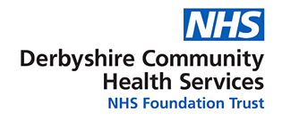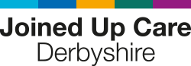

* To provide true local self-management support, help patients to trust their recovery and have the confidence to use less healthcare resource.
* Reduce the burden on our workforce, so they can focus on delivering care.
* Give people the tools to access information and services directly, so they can best take charge of their own health and care.
* Ensure information about people’s health and care can be safely accessed, wherever it is needed.
* Aid the improvement of safety across health and care systems; and
* Improve health and care productivity with digital technology.

**BENEFITS TO PRACTICES**

**BENEFITS TO PATIENTS**

**WHY USE AN APP/DIGITAL SOLUTION?**

* **Provides standardised end to end MSK self-management pathway:** Quick to configure and update with any changes to the pathways.
* **Can be provided to 80% of primary care MSK patients:** Supports the whole journey of a patients care from triage to recovery to prevention and ongoing symptom management.
* **Simple referral processes:** can be accessed via self referral (patient-initiated or via e-consult/similar) or can be prescribed (link sent by text or QR-code.
* **It is available at the first possible opportunity:** Patients do not have to wait, Support is available 24 hours a day, 365 days year.

1. Gives patients more understanding to support/self-management-to take control of their own condition.
2. Includes a symptom checker for where and when to seek help from the NHS.
3. Links to public health services that are local to Derbyshire-Derby’s Livewell service.
4. Translated into 10 different languages/also available in audio recordings.
5. Changing the culture of dependency on the NHS-with self-management at home.
6. Reduction in Primary care appointments (GP & physio) and reduction in prescriptions.
7. Reduction in urgent care attendances and secondary care appointments.
8. Reduction in waiting times for patients as demand is being managed by self management app.
9. The App is completely free for practices and patients to use- commissioned for 2 years.
10. Clinical safety net to ensure the patient can be seen by a clinician quickly if required.

**WHAT ARE OUR AMBITIONS?**

Thank you for working with us on the roll out of the Get U Better app. We believe the App will have great benefits for you and your patients as summarised in this fact sheet:

**What is the**

**GET U BETTER APP?**

For any further information please contact – Sophie Smith – Commissioning Manager ([sophie.smith17@nhs.net](mailto:sophie.smith17@nhs.net))