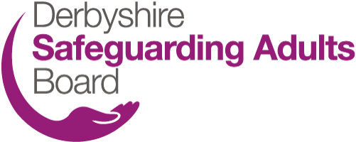

Derbyshire Safeguarding Adults Board
Foetal Alcohol Spectrum Disorder (FASD) webinar Friday 20th November 2020 9.30am-12

During Safeguarding Adults Week 2020 Derbyshire Safeguarding Adults Board is offering a FREE webinar session about pre-natal alcohol exposure and its life-long effects/FASD. The webinar is suitable for professionals from all SAB partner agencies and we also encourage colleagues from children’s services to book a place.

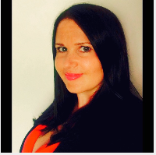
Trainer
The webinar will be hosted by Joanna Buckard from Red Balloon Training. Joanna is a specialist trainer and qualified Health and Social Care lecturer and has been working in the social care sector for 20 years. She previously worked for a Social Services Children and Families assessment team and as a Residential Social Worker for children with significant emotional and behavioural problems. Joanna has been delivering FASD training for 16 years and is a published author. She is also on the expert’s committee for the National Organisation for FASD, has spoken in parliament, and is on the steering group for a FASD project at Salford University. She has spoken nationally and Internationally on FASD for 16 years.

Session objectives
- What is FASD and how is it caused?
- How someone with FASD may present across the lifespan
- When to consider and seek a diagnosis for FASD
- How FASD is linked to safeguarding children and adults
- Who to involve and where to access support

Booking a place: Please email DerbyshireSAB@derbyshire.gov.uk to book a place on this webinar. Places will be booked on a first come first served basis.

