A recent review of pain referrals to secondary care highlighted that 51% are spinal pain related. Therefore we felt that it would be helpful to let you know about a resource that is available to support GPs in managing these patients.

**Musculoskeletal spinal referrals across Derby and Derbyshire**

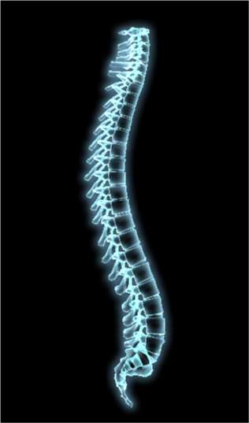

**GP Educational Videos**

Sheffield Consultant Orthopaedic Surgeon, Lee Breakwell, created a set of videos as a training aid for GPs to support the assessment of patients presenting with spinal pain. We have had positive feedback from those who have viewed them. The videos can be found on the NHS Derby and Derbyshire CCG website here:

<https://www.derbyandderbyshireccg.nhs.uk/msk-videos/>

**GP Feedback**

The highest viewed video is entitled **Examination of a patient in a short time.**

“*Thanks to Dr Breakwell for his time in doing these videos. These are extremely helpful in day to day practice and I feel more confident in my overall management of back pain now. Much appreciated*”

**Derbyshire GP**.

Your feedback is appreciated and the completion of [this questionnaire](https://www.surveymonkey.co.uk/r/27HQT8J) will result in a CPD hour’s certificate. We look forward to hearing your suggestions for other MSK areas you would like to be covered in this way.