General Practice Nurse (GPN) Speciality Training Programme

Information Pack for Primary Care –
Derby & Derbyshire CCG

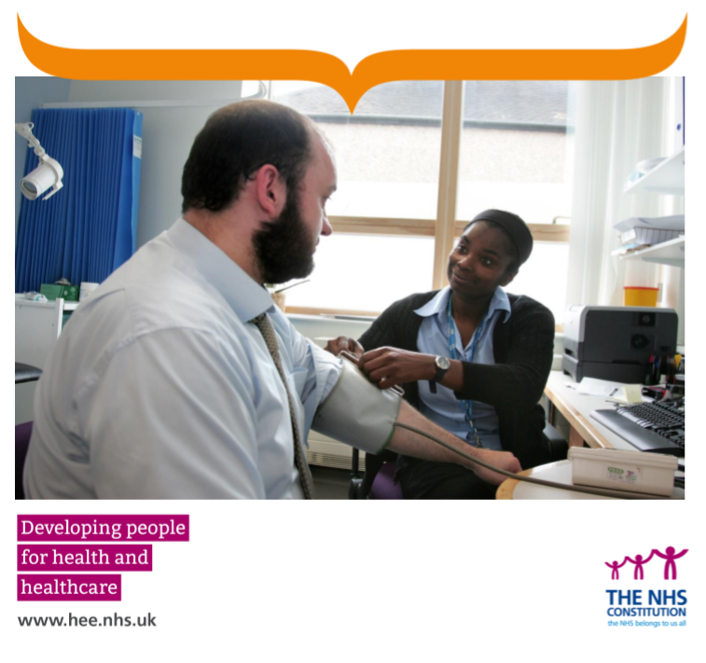

What is the ‘GPN Speciality Training Programme’?

General Practice Nurses (GPNs) need support and development when they first work in a primary care environment. They need to consolidate their skills, practice working independently and with a great deal of autonomy and formulate a development plan that will start them on their journey to a long and productive career in one of the key (and growing) parts of the healthcare economy.
Supporting the development of a new Nurse to be ‘GPN ready’ is crucial - Health Education England, working nationally have piloted a new scheme to encourage this important development work. Derby & Derbyshire CCG are now accepting applications for their second incentive scheme to support new Nurses into General Practice Nursing.

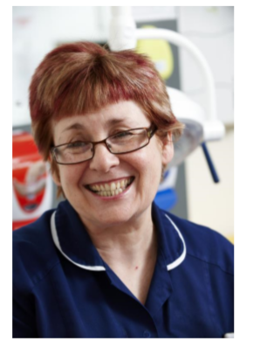

Contents
Information Pack for Primary Care 1
Introduction 2
Background 4
Ongoing Challenges 4
A Supportive and Facilitative Proposal from HEE 5
The Offer 5
What this scheme is NOT 6
How will the scheme work in practice? 7
Who is eligible to apply? 7
Contacts for information 8

Background
General Practice is at a major crossroads; it needs to meet the needs of a growing and ageing population who have more complex and long-term health conditions than ever before. Treatment is no longer acute, or routinely provided in big general hospitals; GP services are being called upon to provide more care to people in community environments - from every child who requires the best start in life, to those individuals who are reaching the end of life and wish to do so in the comfort of their own home, surrounded by those who care for them.
At the same time, the primary care workforce too is ageing, with staff recruited not matching the numbers who have left - or soon will. New staff are not entering the profession at the same rate as those leaving, and many are reaching retirement age soon.
There are already campaigns to encourage new medical staff to consider a career in general practice, the creation of the new role for a Physician’s Associate in this area, and work to examine what role pharmacists can play in the management of a patient’s overall condition. Lots of new opportunities also exist for the vital non-registered parts of the workforce; apprenticeships and healthcare assistant roles already receiving extra support.

Ongoing Challenges
GP practices continue to recruit nurses who are already established practice nurse staff, so this means that they are in essence moving the workforce around rather than attracting the next generation. There are some examples of practice nurses completing return to practice programmes and then being employed in a GP surgery- but these are not present in the numbers required to make a substantial difference. Some nurses are also choosing to join primary care from a post in secondary care- but we are mindful that our secondary care colleagues also have significant nurse shortages, and recruiting staff from there doesn’t create an overall increase to the available nurses in the NHS.
Overall, none of these strategies, however practical and immediate, provide new staff to the workforce and protect the NHS long term.

A Supportive and Facilitative Proposal from HEE

HEE understand and appreciate that primary care is a highly specialised, complex and diverse working environment, which requires its staff to have solid and robust learning experiences that relate to the types of patients seen there.

Although nurses are deemed fit to practise at the point of registration within any environment where nursing activity occurs, this is always within the scope of their skills and experience. Nurses in primary care routinely help manage long term conditions, perform immunisation and vaccination procedures, manage sexual and women’s health interventions, and navigate complex multiple packages of care across the entire life span of a patient.

The Offer
Funding will be provided to those GP practices who offer to appoint a new NMC registered/new to GPN nurse to work in their practice.
The understanding will be that the practice will support and supervise the new nurse in a package of formal academic and experiential supervision and learning over a period of eighteen months.
In the first 9 months, the new nurse employee will have a fully funded place on the De Montfort GPN Fundamentals course commencing January 2021. Their supervisor at the practice will support them to consolidate and strengthen their practical clinical skills. In the second 9 months, this plan will continue, but will also include a 2-day Supervisor/Assessor programme to allow them to then support pre-registration nurses or future trainees on the GPN scheme.

What this scheme is NOT

This scheme is not intended to be used to support any of the routine activity involved with employing a new member of staff. Induction & orientation programmes would apply equally to any new employee, regardless of whether they were new to the GPN role.

Equally, routine professional development (for instance, when a new intervention or technique is recommended in primary care, that requires additional training for any member of the workforce), is not covered within this scheme.

The new nurse should not be used to recruit into a practice solely to fill an existing vacancy, without the means to provide experienced support and supervision.

How will the STP work in practice?
In 2021, the scheme has been limited to 4 places. General practices, or Primary Care Networks (PCNs) are being invited to apply for one of those places. Successful training practices will be involved in the recruitment of their new nurse at interviews on a date to be confirmed – the Practices will be responsible for advertising for the new nurses via the national NHS Jobs website. Shortlisting will be overseen by the Project Lead to ensure all applicants meet the entry requirements.
Once appointed it is anticipated the new nurses will start their 24 month contracts in January 2021.
On completion of the scheme the practice may choose to offer a permanent post or the new nurse will be free/supported to apply for a post elsewhere.

Who is eligible to apply?
An application form will be required from any practice/PCN within the Derby & Derbyshire CCG region wishing to take part in the scheme. (Please see Appendix B – ‘Memorandum of Understanding’ document which will need to be signed in respect of the STP)
They must be able to assure us that they can:
- Provide a trainee GPN a good quality learning environment which involves the whole practice team providing a positive supportive culture of learning. This should be a 24 month fixed term contract for a minimum 30hrs/week to be issued by the practice/PCN
- Allocate their new colleague a named, formal educational supervisor who is an experienced Practice Nurse and who has the skills and protected time to support and guide them
- Provide the nurse access to a range of experience appropriate for a career in primary care
- Allow the new GPN paid study leave to attend the DMU Post Grad Certificate in Practice Nursing programme commencing Jan 2021 – one day a week over 16 weeks for the 9 month programme
- Afford the new GPN protected time for any study/course work and peer support/clinical supervision
- Assist the new nurse to access the 2-day Supervisor/Assessor programme run by local Universities in their second year at the practice and complete follow on study
- Inform us at regular intervals when requested on the progress of the scheme, and advise of any issues at any time during the scheme

In return, the STP will;

- Fully fund the DMU course for each trainee GPN in 2021/22.
- Provide each practice a total of £3,800/year (pro rata) for each new nurse, to be used to support their release for attendance at DMU and any other training required.
- Provide a Peer support network and group clinical supervision for the trainee.
- Organise reviews of the scheme, collecting data from individual practices and new nurses employed whenever is appropriate to ensure the effective progress of the scheme

Contact for questions
The scheme is now taking applications from practices/PCNs who wish to be considered for Jan 2021.
We appreciate that you may have questions about the scheme, and in the first instance please direct them to the Project Lead, Deb Draycott. You can contact her on ddraycott@nhs.net

