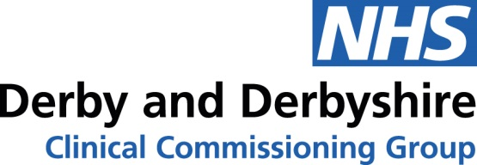

Email: helen.hipkiss@nhs.net

Date: 21st August 2020

Dear Colleague

Re: NHS Continuing Health Care – Fast Track referrals

The COVID - 19 pandemic, and the emergency procedures that were introduced in response, required the NHS to suspend the continuing healthcare processes delivered by Commissioning Care Groups (CCGs) for a period of up to 6 months. Section 14 of the Coronavirus Act 2020 changed the duties of CCGs and NHS England to carry out assessments in respect of Continuing Healthcare (CHC).
The Phase 3 letter received from NHSE/I on 31st July as a result of the Governments agreement that the NHS EPRR incident level would move from Level 4 to Level 3 now outlines the expectation that CCGs must resume NHS Continuing Healthcare assessments from 1 September 2020.
We therefore need to reinstate the requirement to complete the Fast Track Pathway Tool for NHS Continuing Healthcare from 1 September 2020.

The combined Fast Track referral, consent and care needs document that reflects the National Fast Track Pathway tool, evidences that appropriate end of life discussions have taken place with the patient/family, provides appropriate consent to share sensitive information and provides a comprehensive assessment of the care and support needs that each individual and their family requires.

I have attached the referral documentation for you to now disseminate to members of the relevant teams who are currently involved in assessing and referring for Fast Track to Continuing Healthcare to enable the individual’s needs to be urgently met as they have a rapidly deteriorating condition which may be entering a terminal phase.

I have also attached guidance for using the Fast Track pathway.

Please do not hesitate to contact my Assistant Director of Quality, Nicola MacPhail Nicola.macphail@nhs.net should you have any concerns or comments related to the changes outlined above.

Kind Regards,

Helen Hipkiss – Director of Quality Derby & Derbyshire CCG.

