NHS People Pulse
Communications toolkit
For HR and communications teams
NHS England and NHS Improvement
Contents

1. Introduction 2
2. Promoting the survey 2
3. How it works and timescales 3
3.1 Key dates 3
3.2 How it works 3
4. Visuals 4
4.1. Logo 4
4.2. Images for digital and print channels 5
5. Narratives 7
6. NHS People Pulse FAQs 8

Introduction

The link between high engagement levels among our staff and the quality of care they deliver to our patients is well documented. Organisations can achieve greater levels of engagement by contributing to the employee experience overall. Evidence highlights the importance of employers giving employees effective channels for voice; listening carefully to their concerns on which to take action to improve experience.

A mixed methodology of listening draws upon different strengths; employee surveys provide a representative view of experiences across the totality of an organisation, whilst qualitative methods provide a richer understanding of individual employee experiences. The NHS People Pulse is provided, free of charge, for organisations to build into their methodologies.
As we enter the next phase of the COVID 19 response, the People Directorate is supporting trusts with a national online NHS People Pulse survey. The two-weekly survey is optional, entirely anonymous, and being made available to all Trusts and organisations that would wish to take part.
The national online NHS People Pulse is offered free of charge until 31 January 2021 and participation in it is entirely voluntary. It is a fortnightly, quick pulse check – it should only take 5 minutes to complete - and provides detailed demographics.
The survey will give the NHS a critical national, regional and local view of employee experience and wellbeing to support enhancing existing local engagement activities .It will allow trusts to obtain data on experience quickly and enable the national team to wrap around the right kinds of support for colleague health and wellbeing.

Promoting the survey

This toolkit is for HR and communications professionals within NHS trusts, CCGs, ICSs and STPs. Please promote the survey to all NHS staff through your intranets, newsletters, cascade briefings, social and any other key internal channels.
This toolkit contains:
- The People Pulse logo
- Visuals for use with digital and print communications channels
- Social media messaging
- Text for key narratives
- A set of FAQs

How it works and timescales

3.1 Key dates
- Trust leaders’ briefing: to be sent out through the NHSE/I overall briefing to all Trust and system leaders on Wednesday 1 July
- Launch date: 1 July
- End date: 31 January 2021

3.2 How it works
- A universal link will be communicated to Trusts/organisations interested in utilising this free toolkit.
- The link is https://www.nhspeoplepulse.com/
- Data will be

  - reviewed at the national level to inform policy and prioritisation, with a fortnightly read out at NHS England and NHS Improvement’s senior team meetings

  - made available to individual Trusts/organisations, regional contacts and the People Directorate and

  - used to inform local, regional and national improvements in how staff are supported

- The data will not replace the representative data collected from the NHS Staff Survey.
- The service offered free of charge (until 31 January 2021) to NHS England and NHS Improvement includes
- end to end business support
- sample design
- question development
- data analysis and reporting leading to analysis of information and interpreting action.

- Responses record protected characteristics, including ethnicity, which will provide continued evidence for understanding how we can improve employee experience.

- The question set is divided into two – a set of core questions included in every cycle of the survey and a set of flexible questions which will be chosen to explore some issues in depth or respond as a follow up to the previous responses.

- The question will be simple and straightforward and will be mostly ranked on a sliding scale, for example:
- My organisation is keeping me informed about the impact of the coronavirus on our working lives.
- My organisation is proactively supporting my health and wellbeing in the current environment.

- The survey also allows for qualitative data to be collated and analysed, for example, in relation to any feedback participants may wish to add about the NHS response to coronavirus.
- Responses will be anonymous, questions with fewer than ten responses will not be reported on at a trust level

- A link will be included to the www.people.nhs.uk microsite and the main NHS website to signpost results and offer the option of a ‘you said, we did’ format including the development of mental health and wellbeing support.

- This offer is complementary to a recent arrangement introduced through the NHS Staff Feedback hub, which is a closed group of between 100-500 members of staff regularly engaged to provide business insight to check on how staff communications are landing and act as a barometer of success

- This is being offered as an improvement tool in response to Covid-19, and information will be not be used for trust to trust or regional comparisons given it will not be a representative survey in the same way as the annual NHS Staff Survey is

Visuals

Logo
The name of the survey is NHS People Pulse. The People Pulse logo should be used in line with overall NHSE/I brand guidelines (i.e., the Pulse logo on the left and the NHS lozenge above right (www.england.nhs.uk/nhsidentity/identity-guidelines/partnership-branding/).

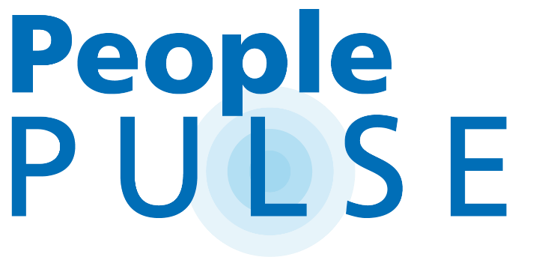

Images for digital and print channels

Desktop, mobile and tablet (including ESR) in landscape and portrait options

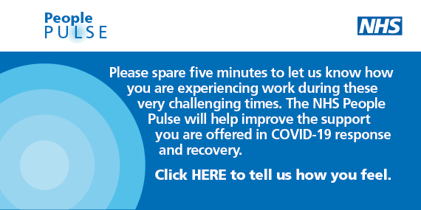
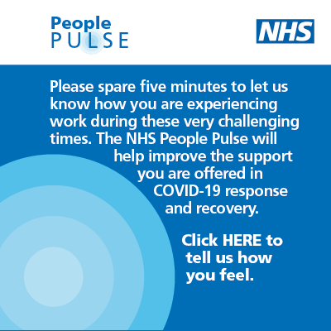

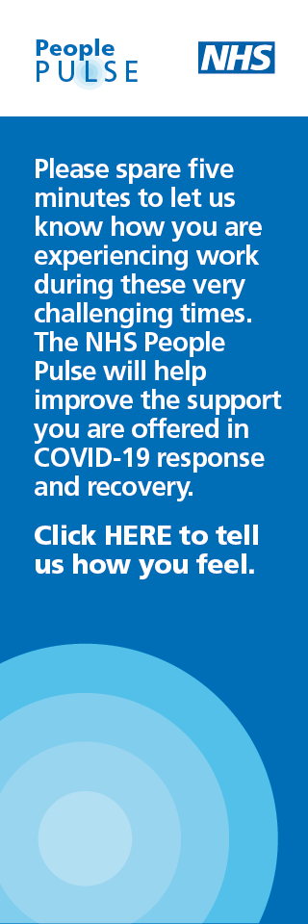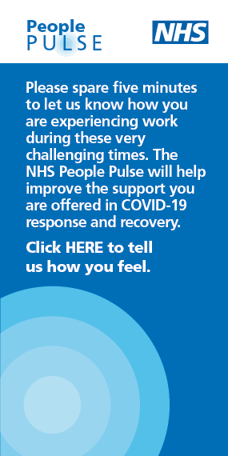

Screen saver
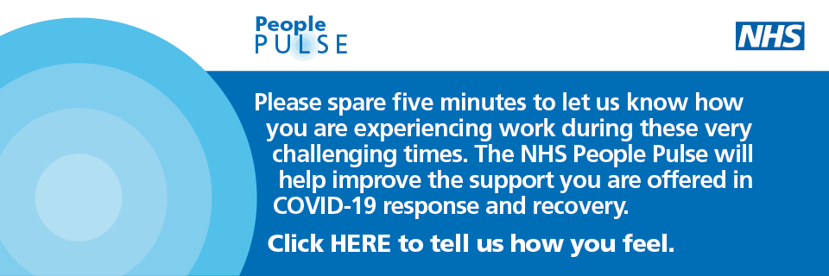

Social media cards and social media messaging
For launch of survey and general awareness

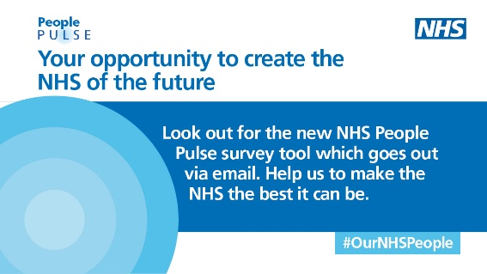
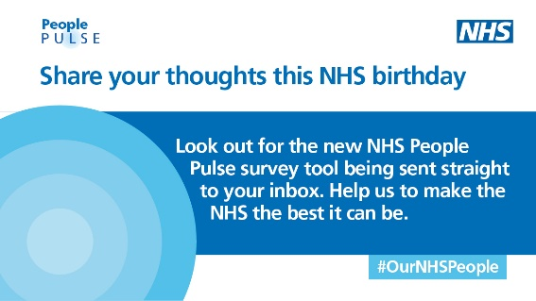

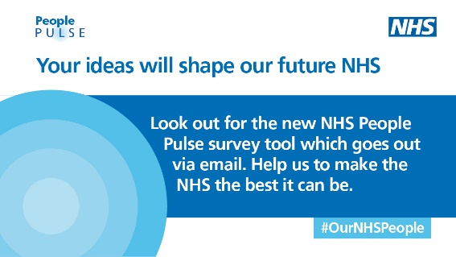

Narratives

Narrative for use within organisations
Listening and responding to your concerns is as important as ever and your health and wellbeing remains a top priority for us. So as we enter the next phase of our response to coronavirus and safely bring back NHS services, we want to continue to provide the support our staff deserve and need. That is why, in partnership with NHS England and Improvement, we have implemented a new staff ‘pulse check’ which is entirely anonymous and voluntary. NHS People Pulse will give us another way to listen to your views and help improve the support we provide during the Covid-19 response and recovery. Your feedback will also inform local and national changes that improve the experiences of our people and patients.
Please take just five minutes every two weeks to check in on a number of important questions via this quick and simple People Pulse.
Click now to tell us how you feel.

NHS People Pulse FAQs

- Who is NHS People Pulse sent to?
It will be sent to all NHS provider commissioning organisations who want to use the NHS People Pulse within their organisation. Organisations just need to register their interest by emailing nhsi.peoplepulse.nhs.net
- What is NHS People Pulse?
The NHS People Pulse is designed as a simple listening tool for both national and local leaders to use when designing and implementing further support to our NHS People.

- How do you know the contacts are up to date?
We do not require you to provide any contact details. You can send it to all staff, and responses are anonymous. Therefore there is no need for the contacts to be kept up to date.
- How many people will be surveyed?
We would like to encourage all NHS organisations in England to participate and to send the link to all staff, there is no set number that we anticipate completing the survey.
- Does it include social care / AHPs – any other groups people may not think are included?
The survey applies to any professional employed by an NHS organisation, this includes all staff groups, for example GPs, Healthcare Assistants, Physiotherapists, Pharmacists, Doctors, Maintenance Assistants, Administrators, etc. However, the survey does not cover anyone employed by a local authority.
- How is it sent?
A link to the survey is circulated to leaders in organisations. We encourage organisations to circulate the link internally to all staff
- If I have any issues, who do I contact?
If you have any issues with accessing the link on your organisation’s devices, please contact your IT department.

For any other queries please email nhsi.peoplepulse@nhs.net
- Is it confidential?
Yes, you can access the survey by following a universal link where you will not be asked to fill in personal information such as name and date of birth. However, we will ask you to provide some demographic information (e.g. ethnic origin, age, job type) in order to explore the results for different populations.
- Who will see the results?
The results will be available through an online dashboard which will be accessed by leaders in your organisation, region and in the national team. We hope that the results will be shared with staff locally.

- What demographic information is collected?
We are collating the following information:
- ethnic origin
- sexual orientation
- disability
- gender
- age
- carer/childcare responsibilities
- job role type
- organisation
- working arrangements (remote working or working on site)

- How will my data be used?
The data will be processed and help shape action required to support decisions linked to implementing support to staff and organisations during Covid19.
- Can I opt out of any questions before I send it?
Some questions will be mandatory to complete when you participate in the survey. This is to help us understand how best we can support you and organisations in response to Covid19. You will not have to answer all of the demographics questions by choosing ‘prefer not to answer’ option.
- What will it survey?
The NHS People Pulse will survey how employees and employers in the NHS in England are responding to the pressures that Covid19 may have put on them at work and at home. This may involve surveying how supported, motivated or anxious you may feel and ask you what other support would make the biggest difference of your experience at work at this time.
- Can I choose my own reporting?
No, reports will be accessible via the dashboard 48 hrs after each cycle end. The reports may be accessed by three individuals nominated by the organisation as well as regional and the national team. The platform will allow each Trust to apply different filters when looking at the data.
- As a leader in my organisation, can I add questions to the survey?
Yes, you can suggest adding some questions to the flexible pool of questions by submitting them to nhsi.peoplepulse@nhs.net
- How often will it take place?
A new survey cycle will take place every two weeks starting from 1 July 2020 i.e. the first cycle will run 1-14 July; the second, 15-28 July, etc.
You may notice that some of the questions may change from one cycle to another in addition to the core questions which will be asked during each cycle. This is to allow us to explore various aspects of response to Covid19.
- How soon will I get the results back?
The results will be available on the dashboard accessible by leaders of organisations 24 hours after the survey cycle closes. This is with exception of the first cycle when the results will be available 5 working days after it closes. This is to allow time for any adjustments to be made to the reporting dashboard.
- Who do the results get sent to?
The results are directly accessed through an online portal by up to three nominated members of each organisation, who are able to download the reports and are free to share them widely within the organisation
- How do I get access to the data?
Named individuals in organisations will have access to the analytics dashboard where they can access detailed results.
- Will the results be used in internal / external comms and if so, how?
National aggregated results will be published on the www.people.nhs.uk website. The leadership team in your organisation will have access to local results for your organisation.
- Are these official figures?
Participation in the survey is on voluntary basis therefore the data may not be representative of each organisation. The data will provide an umbrella view for regional and national consideration and allow triangulation of information at a local level to better understand and support actions to improve employee experience.
- What about the Staff Survey / Friends and Family? How does this fit in?
Local Friends and Family test has been paused in order to allow organisations to act on the immediate response to Covid19. The NHS People Pulse survey will not replace either FFT or national Staff Survey. However, it does broaden local and national intelligence by listening and acting on the views of NHS staff throughout our response to Covid19.

Engaging for Success – enhancing performance through employee engagement – Macleod and Clarke, 2009 Employee engagement and NHS Performance – West and Dawson, 2012 Culture and Leadership Programme – NHS Improvement and King’s Fund

