

This resource pack has been designed to promote excellence in nutrition and hydration care in the care home setting.

If you have any queries about the information within this booklet, please contact:

* The North Derbyshire Dietitians on: 01246 512173
* The South Derbyshire Dietitians on: 01332 258214

**The Derbyshire Nutrition and Hydration Pack for Care Homes**

Endorsed by:

|  |
| --- |
| **Introduction** |
| The Nutrition Support Team work with nursing and residential care homes in your locality to support staff to provide all residents with excellent nutritional care, in line with Care Quality Commission (CQC) Regulation 14: Meeting Nutritional And Hydration Needs. The care home population is diverse with a wide range of nutrition and hydration needs and challenges. Those in residential care settings may have a requirement for ‘healthy eating’ or ‘eating for health’. ‘Eating for health’ better reflects the needs of residents who require a special / therapeutic / more energy dense diet. Each resident requires a diet that meets their own health and nutrition needs. Good nutrition and hydration is fundamental in health and disease and impacts on recovery times, quality of life and health outcomes including premature death.  An award scheme has been developed to acknowledge best practice. All care homes who meet the expectations set out in this booklet will be awarded with the ‘Nutrition and Hydration Award’. Receiving the award demonstrates your commitment to providing high standard nutrition and hydration care for your residents. A certificate will be provided to all care homes who meet the award requirements and this will be valid for two years. For care homes achieving the highest standards of nutritional care, a Certificate of Excellence will be awarded. Care homes achieving a satisfactory standard will be issued with a Certificate of Award.  This resource pack includes all of the information required to support you to achieve the Nutrition and Hydration Award standards and to provide excellent individualised nutrition and hydration care to all of your residents. |
|  |
| **Nutritional Screening** |
| All residents admitted to care homes should be screened for malnutrition using an accredited screening tool, such as the Malnutrition Universal Screening Tool (MUST) produced by BAPEN (see page **32** - **35**).  Nutritional screening should be completed **within 24 - 48 hours** of each resident’s admission. **and** screening should be **re-assessed** **at least** **monthly** for all residents.  The MUST screening consists of 5 steps:   * Step 1: BMI score * Step 2: Weight loss score * Step 3: Acute disease effect score * Step 4: Overall risk of malnutrition * Step 5: Management guidelines   Some care homes will have their own Nutritional Screening Tool and if this is the case the dates along with the weight, heights and scores should be documented on this tool. |

|  |  |  |
| --- | --- | --- |
| **Screening Step 1: BMI Score** | | |
| The Body Mass Index (BMI) should use a resident’s **most recent weight**. Weight should be recorded in kilograms (kg) and the resident’s height should be recorded in metres(m).  To calculate the BMI score, a BMI chart can be used (see page **33**) or the following equation:  **Body mass index = weight (kg)**  **height (m)²**  Record the BMI in the resident’s notes, and the MUST score based on the information in the table below.   |  |  |  | | --- | --- | --- | | **BMI** | **BMI MUST score** | **Nutritional risk** | | Greater than 20 | 0 | Low | | Between 18.5 and 20 | 1 | Medium | | Less than 18.5 | 2 | High |   **Guidance on obtaining a weight:**   * Measure weight at least monthly for all residents using suitable, regularly calibrated standing, seated, hoist or wheelchair scales. * If your resident’s weight varies greatly from the last documented weight, re-weigh them to ensure that no errors have occurred. * To promote accuracy, aim to record resident’s weights at a similar time each month, at a similar time of day, and in light clothing. Ensure that the floor surface is level. * If you are unable to weigh a resident, you can instead estimate BMI using mid upper arm circumference (MUAC) (see page 35). Please note that this estimated BMI **should not** be used to calculate the residents MUST score.   **Adjusting Weight For Amputations**  You may have residents with amputations and as a result, their BMI from their amputation weight is inaccurate. To calculate their adjusted weight, please use the following:   |  |  | | --- | --- | | Below knee | Current weight (kg) x 1.063 | | Full leg | Current weight (kg) x 1.18 | | Forearm | Current weight (kg) x 1.022 | | Full arm | Amputation Calculation  Current weight (kg) x 1.05 |   **Guidance on obtaining a height measure:**   * A standing height measurement in metres should be taken where possible on admission to a care home using either a stadiometer or tape measure secured to a wall. Height measurements do not need to be repeated unless there are concerns over the accuracy of the first measurement. * If you can’t obtain a resident’s height, you can try to obtain an ulna length which will give you an estimated height (see page **35** for conversion chart). If this is not possible, you may be able to obtain a self-reported height or a height reported from a family member. If such a height is used for calculating the MUST score this should be clearly documented in the residents notes. Alternatively, a height measure could also be obtained from the residents general practice records. | | |
| C:\Users\KellyB3\AppData\Local\Microsoft\Windows\Temporary Internet Files\Content.IE5\BRCD45M5\great_idea[1].jpg | **Top Tip:** Set a weighing day for each section of your care home, to ensure that residents are weighed at a similar time each month e.g. the afternoon of the 1st day of each month. | |
|  | | |
| **Screening Step 2: Weight Loss Score** | | |
| The weight loss score is calculated as a percentage, using the **most recent weight** and the resident’s normal / usual weight **from the last 3-6 months**. It is common for your resident’s weight to fluctuate within a small margin above or below their normal weight (+/- 5%).  To determine percentage weight loss, you can use a chart (page **34**or a local version) or you can calculate it using the following equation **(weight must be in kg)**:  **% weight loss = (previous weight - current weight ) ÷ previous weight x 100**  Record the % weight loss in the residents notes, and the MUST score for Step 2.   |  |  |  | | --- | --- | --- | | **BMI** | **BMI MUST score** | **Nutritional risk** | | Less than 5% | 0 | Low | | Between 5 – 10% | 1 | Medium | | Greater than 10% | 2 | High |   Obtaining a normal / usual weight may be difficult for a new resident. This might be available from the resident’s general practice records, from the resident themselves or their relatives’. If the resident’s weight history is not available over the past 3-6 months, you will be unable to complete this step. Instead, complete Step 1 and Step 3 and record the reason why Step 2 has not been completed. | | |
| C:\Users\KellyB3\AppData\Local\Microsoft\Windows\Temporary Internet Files\Content.IE5\BRCD45M5\great_idea[1].jpg | | **Top Tip:** If you are unable to obtain a weight history for the resident or are finding it difficult to judge the weight loss, you could ask family, check with the GP, or use family photographs of the resident to visualise whether the resident has lost a significant amount of weight. |

|  |  |  |
| --- | --- | --- |
| **Screening Step 3: Acute Disease Effect** | | |
| **Please note: This step usually only applies to patients in hospital, and very rarely generates a score in the community setting.**  Step 3 generates a MUST score if a resident has been acutely **and** critically ill **and** there has been (or is likely to be) **no** nutritional intake for more than 5 days. If these criteria are met, the resident would be given a MUST score of 2.  In most circumstances in the community setting, Step 3 **will not** apply to your residents. Therefore, for this step, most residents will be given a MUST score of 0. | | |
|  | | |
| **Screening Step 4: Calculate Overall Risk of Malnutrition** | | |
| To determine the overall MUST score, add the scores from Step 1, Step 2 and Step 3. Please see the below table:   |  |  | | --- | --- | | **Total MUST Score** | **Risk Of Malnutrition** | | 0 | Low | | 1 | Medium | | ≥2 | High |   In a care home, the highest possible MUST score is usually 4. In *very rare circumstances* when a resident scores 2 for Step 3, the highest overall MUST score would be 6. | | |
|  | | |
| **Screening Step 5: Management Guidelines and Care Planning** | | |
| When you have determined the overall MUST score, refer to the Algorithm for Nutrition Care Planning to identify the appropriate care pathway for your resident’s needs (see page **29**).  Your resident’s diet may need to change depending on their MUST score. Nutrition care plans and the aim of any nutritional interventions should be reviewed at least monthly. This is to reflect changing MUST scores and any changes to the management of their nutrition and hydration needs.  Regular communication with the catering staff will ensure that they are aware of any nutritional changes, and that all residents receive the appropriate diet for their needs. To document resident’s nutritional needs conveniently for catering staff, the Monthly Catering Communication Sheet (see page **26** - **27**) can be used. | | |
| C:\Users\KellyB3\AppData\Local\Microsoft\Windows\Temporary Internet Files\Content.IE5\BRCD45M5\great_idea[1].jpg | **Top Tip:** Provide your general practice with a list of the resident’s weights regularly (at least 3 monthly), so that they can update their medical records. This will improve the overall quality of integrated care provided | |
| **End of Life Care** | | |
| For residents who are in the last days of their life, their nutritional intake should maximise their quality of life by providing comfort, symptom relief and enjoyment of food. Nutritional screening, weighing the resident and prescriptions for oral nutritional supplements (for weight gain or maintenance) are **no longer appropriate** because they are not likely to provide any significant nutritional benefits.  During this time, the main nutritional priority for residents is to offer diet and fluids that are enjoyed and tolerated. This promotes comfort and quality of remaining life. | | |
|  | | |
| **Dysphagia and Texture Modified Diets** | | |
| Residents with difficulty in swallowing foods safely (oropharyngeal dysphagia) may require a texture modified diet. To reduce their risk of choking or aspiration (food or liquid entering their airway), a Speech and Language Therapist (SLT) may have suggested texture modifications to their foods and/or liquids. The British Dietetic Association (BDA) and the Royal College of Speech & Language Therapists (RCSLT) agreed to adopt the International Dysphagia Diet Standards (IDDSI) across the country from April 2019. For more information on IDDSI and its criteria, please see pages 30-31.  A texture modified diet should only be given to residents following the advice of a healthcare professional, such as a SLT. Resident’s need for a modified texture diet should be regularly reviewed, as their requirements for this may change over time. Changes should be communicated to **all** staff involved in a resident’s food preparation and provision as well as family who may bring in snacks. It is important for texture modified meals to remain appetising. Every effort should be made to maintain the usual colour, nutrient content, flavour and appearance of foods served. Moulds can be used to improve the appearance of texture modified meals. Well planned menu rotation is also encouraged, to ensure that a variety of colourful, flavourful, appealing meals are served and to prevent taste fatigue for these residents as this may lead to a reduced food intake.  To achieve an appropriate texture modified menu as suggested by SLT, additional fluids are often added to foods to moisten or aid the pureeing process. This results in a larger volume of food which a resident is unlikely to eat. To ensure that resident’s receive adequate nutrition, texture modified meals often require fortification (please see page **9** - **11**). If there is any concern regarding a residents’ texture modified diet requirements, please contact their discharging SLT or Dietitian for more information. | | |
| **Promoting a Positive Meal Experience** | | |
| Before and during meal times, steps should be taken to promote a positive meal experience. The tips below, will ensure your residents have a good meal experience and this can contribute to them eating more at meal times.   * Prepare residents for meal times by encouraging them to help set out the dining tables. Talk about what time it is and what the day’s menu choices are. Encourage residents or ensure that care staff wipe down the dining room tables or bed side tables before meals are served. * Ensure all residents have an opportunity to visit the toilet and wash or wipe their hands before meals are served. * Ensure that residents have the right equipment available at meal times e.g. glasses, hearing aids, well-fitting dentures, special cups, cutlery and plates if needed. * Ensure all residents are sitting in a supported, upright position (45 degrees minimum). * Keep the eating environment as calm as possible with minimal distractions. Some residents may eat better in company in a dining room whilst others may be better sitting alone in a lounge or in their own room. Consider their individual needs. * Ask residents about their food and drink preferences at meal times. * Aim for maximum independence during meal times but continue to observe, encourage and assist as needed. * Help residents to open any packaging or cut up meals if needed. * Ensure that all residents have their meal, suitable for their needs, as well as a suitable drink in reach. * Avoid using large spout beakers. These deliver more fluid to a patient than they would normally swallow. * Avoid all spouts if possible. If one is needed for a resident, use a small one.   Having to be fed can be emotive for many residents as they view this as further deterioration in their abilities. It is important to ensure that dignity is maintained when helping a resident to eat their meal. Implementing the following can help boost nutritional intake and again improve the residents’ meal experience:   * When feeding a resident, sit slightly to one side at eye level. * Feed at a pace appropriate to the resident, **do not** rush. Give the resident plenty of time to swallow. * Tell the resident what you are feeding them at each mouthful and don’t mix foods. * Don’t overload the spoon or fork.   If there are concerns with a resident’s nutritional intake or weight, report this to other care staff and document what the resident has eaten and if any difficulties were experienced. Please see our example food chart section on page **22**. | | |
| C:\Users\KellyB3\AppData\Local\Microsoft\Windows\Temporary Internet Files\Content.IE5\BRCD45M5\great_idea[1].jpg | | **Top Tip:** If your residents are prescribed a supplement, **do not** give these at meal times. Encourage your residents with their meals and puddings so that they get the maximum nutritional benefit from their meal. Supplements should be offered between meals in addition to suitable snacks and high calorie drinks. |
| **Healthy Eating** | | |
| Residents who do not have specific nutritional requirements due to illness or disease will require a healthy, balanced diet, in line with the Eatwell Guide (see page **28**). For these residents, we aim for a healthy weight which is indicated by a BMI of 20-25kg/m². The Eatwell Guide provides advice on the following:  **Fruit and vegetables** – At least 5 portions should be eaten, including a variety of fruit and vegetables every day. These can be fresh, frozen tinned, dried or small amount of juice (150mls of fruit juice counts as 1 portion).  **Starchy carbohydrates** – This includes potatoes, bread, rice, pasta and other starchy carbohydrates and should be included at every meal. Choose wholegrain or higher fibre versions with less added fat, salt and sugar.  **Protein–rich foods** – 2-3 portions should be offered daily. This includes meat, fish, eggs and pulses. Choose lean cuts of meat, and minimise the amount of processed meat eaten such as sausages and bacon. It is advised that 2 portions of fish are eaten weekly, 1 of which should be oily like salmon or mackerel. If vegetarian or vegan, residents should be offered a variety of protein containing foods such as beans, lentils, chickpeas, soya products, nuts and nut butters, chia seeds, ground linseed, hemp and pumpkin seeds, vegan meat alternatives. If vegetarian, vegetarian meat-alternatives and free range eggs can be offered.  **Calcium-rich foods** – 2-3 portions should be offered daily including milk and milk products including cheese and yoghurt. Cheese needs to be animal rennet free if vegetarian. If vegan, offer plant based milks fortified with calcium such as fortified almond, coconut, hazelnut, hemp, oat, rice and soya milks and yoghurts or calcium-set tofu. Foods that contain smaller but notable amounts of calcium include kale, pak choi, okra, spring greens, dried figs, almonds, sesame seeds, sunflower seeds.  **Fats and oils** - Choose unsaturated oils and use in small amounts. If vegan, choose vegetable oils, fats and spreads.  The government has produced information on providing a healthy diet to care home residents. Nutrients of specific consideration for your residents include:   * Fibre (both soluble and insoluble), to promote regular bowel opening (when consumed with adequate fluids). * Iron, to prevent anaemia. Absorption is enhanced when iron rich foods are consumed alongside foods and drinks rich in vitamin C. * Calcium, to maintain bone density and prevent osteoporosis development or progression. | | |

|  |
| --- |
| **Vegetarian and Vegan Diets** |
| Vegetarian and vegan diets are on the rise. The Vegetarian Society (UK) defines a vegetarian as ‘someone who lives on a diet of grains, pulses, nuts, seeds, vegetables and fruits with, or without the use of dairy products and eggs. A vegetarian does not eat any meat, poultry, game, fish, shellfish or by-products of slaughter’ (www.vegsoc.org). The Vegan Society (UK) defines veganism as ‘a way of living which seeks to exclude, as far as is possible and practicable, all forms of exploitation of, and cruelty to, animals for food, clothing or any other purpose’. It is therefore an ethical movement, which has protected status, rather than just being a diet (www.vegansociety.com).  Reasons for following a vegetarian or vegan diet can vary and may include religion, parental or peer influences, animal welfare, environmental issues and health reasons. As people age, they have a decreased need for energy but increased requirement and/or decreased absorption of some nutrients. This combined with a smaller appetite and possible physical limitations means that a nutrient dense vegetarian or vegan diet should be eaten in line with individual nutritional requirements. There are a number of suitable vegetarian and vegan alternative foods and these are generally found in supermarkets, with more unusual products available in health food shops or online. Appropriate labelling of foods as ‘suitable for vegetarians’ or ‘suitable for vegans’ has made it easier to identify appropriate products. If you do not provide in house catering, please check that your caterer provides both vegetarian and vegan diets. Without careful management, vegans may develop a number of nutritional deficiencies including B12, Calcium, Fats & Omegas, Iodine, Iron, Protein, Vitamin D and Zinc. Please ensure that vegan residents have a vitamin and mineral supplement suitable for vegans. |

|  |  |
| --- | --- |
| **Food Fortification** | |
| A fortified diet describes meals, snacks and drinks to which additional nutrients have been added. This is usually achieved by adding foods such as cream, butter, oil, full fat milk, cheese and dried skimmed milk powder. These can be added during food preparation and cooking, or added to the finished meal. The aim of food fortification is to enrich foods to provide a higher nutrient density (specifically calories and protein) without increasing the portion size.  Calories are also known as “energy”. Increasing calories can help to prevent weight loss, and in sufficient quantities can promote weight gain. Protein is fundamental to help with wound healing and maintaining skin integrity, as well as other bodily functions. Protein rich foods that can be used to increase the protein content of meals include dried skimmed milk powder, milk and grated cheese. A range of vitamins and minerals are essential for health and all bodily functions. If a resident is not eating well and losing weight, it is very likely that they are also missing out important vitamins and minerals. Therefore, in addition to ensuring that the resident is consuming sufficient calories and protein, it is important that they are also encouraged to eat a wide range of foods, including a range of different coloured fruits and vegetables. If the resident chooses to eat a very restrictive diet, they may require an A-Z multivitamin and mineral supplement – available to purchase over the counter.  Residents who are at moderate to high risk of malnutrition (indicated by a MUST score of ≥1), or who have a poor appetite, should be offered smaller, fortified meals with nourishing snacks and nourishing drinks between meals (see suggestions on pages **12** and **13**). The appetite will not be stimulated when there are long gaps in between eating occasions – that is more likely to further worsen a poor appetite. A little and often approach is usually much more successful to increase intake.  Food fortification should be completed on an individual basis to ensure that it is effective. For example, adding a few tablespoons of double cream to 10 portions of mashed potatoes would not be adequate food fortification for those 10 residents. Please see some examples of food fortification on page **10**. Please note for vegetarian residents, cheese should be animal rennet free.  For more information on food fortification, please watch the following video:  <https://www.youtube.com/watch?v=2tS7fP7aUy8&feature=youtu.be> | |
| C:\Users\KellyB3\AppData\Local\Microsoft\Windows\Temporary Internet Files\Content.IE5\BRCD45M5\great_idea[1].jpg | **Top Tip:** Encourage your care staff to sit down in the dining room and eat their meals with your residents. This could encourage residents to eat and drink well. |

|  |  |  |  |  |  |  |
| --- | --- | --- | --- | --- | --- | --- |
|  | | | | | | |
| **Food Fortification Ideas** | | | | | | |
| **Food (Approximate Quantity)** | **Approximate Nutrition Provided Before Fortification** | | **Fortified With** | | **Approximate Nutrition Provided After Fortification** | |
| Calories (kcal) | Protein  (g) | Calories (kcal) | Protein  (g) |
| Mashed potato (1 scoop) | 45kcal | 1g | * 1 knob of butter * 1 tablespoon of double cream * 30g grated cheese | | 320kcal | 8g |
| Scrambled eggs (2) on hot buttered toast (1 slice) | 330kcal | 20g | * 1 tablespoon of double cream * 30g grated cheese | | 525kcal | 27g |
| Custard (small portion) made with whole-milk (100ml) | 120kcal | 4g | * 1 tablespoon of double cream * 1 heaped teaspoon of milk powder | | 235kcal | 8g |
| Porridge made with whole-milk (160g) | 185kcal | 8g | * 180ml full fat milk * 1 tablespoon milk powder * 2 tablespoons of double cream * 1 teaspoon of honey | | 375kcal | 9g |
| Baked beans or ravioli  (150g) | 125kcal | 7g | * 30g grated cheese (match-box size) | | 250kcal | 15g |
| Rice/pasta (200g) | 250kcal | 5g | * 2 teaspoons of oil or butter | | 300kcal | 5g |
| Serving of  vegetables (80g) | 15kcal | 0g | * 1 knob of butter | | 90kcal | 0g |
| Fruit canned in  syrup (100g) | 57kcal | 0g | * 3 tablespoons of evaporated milk | | 125kcal | 4g |
| Cream of Tomato Soup  (1/2 400g tin) | 200kcal | 3g | * 1 heaped tablespoon of milk powder * 2 tablespoons of double cream | | 400kcal | 9g |
| **C:\Users\KellyB3\AppData\Local\Microsoft\Windows\Temporary Internet Files\Content.IE5\BRCD45M5\great_idea[1].jpg** | **Top Tip:** Instead of using gravy, look at adding white sauces, cheese sauces, pepper sauces or parsley sauces made with fortified full cream milk (see page 13) to really boost the calorie content of meals for those residents who require a fortified diet. | | | | | |
| |  |  |  |  | | --- | --- | --- | --- | | **Vegan Food Fortification** | | | | | Items below can be used to fortify foods for example:  50g porridge oats made with 270mls soya milk = **468kcals**  Add 30mls soya cream, ½ sliced banana, 15g peanut butter, 15g syrup = **668kcals**  Please note coconut products are higher in calories but also in saturated fats. | | | | | **Vegan Alternative** |  | **kcal (g/ml)** | **Protein (g)** | | Cheese – on sandwiches/toast, stir into baked beans, add to mashed potato, add to soups, on top of jacket potato | Supermarket ‘Free From’ cheese – 30g  Supermarket Free From’ soft cheeses – 30g | 86  86 | 0  2 | | Milk – fortify with soya / oat/coconut cream and make nourishing hot or cold drinks | Alpro Growing Up Milk (soya) – 250mls  Oat barista milk – 250mls | 163  148 | 6.3  2.5 | | Yoghurt – fortify with cream, add to fruit smoothies | Soya fruit yoghurt -125g  Soya Greek style yoghurt – 150g  Coconut yoghurt – 125g | 85  123  164 | 5  7  2 | | Ice cream – add to milkshakes, enjoy with fruit or vegan puddings  Dessert – fortify with cream, add to milkshakes | Soya – 100g  Soya – 125g  Coconut – 130g | 166  104  150 | 2.3  4  2 | | Butter – on toast, sandwiches, tea cakes, fruit loaf add to vegetables and mashed potatoes  Use to fry and roast | Vegan spread – 15g  Vegetable oil -15ml | 80  124 | 0  0 | | Cream – add to yoghurts, desserts, smoothies, nourishing drinks, enjoy with fresh fruit | Coconut cream – 30mls  Soya cream – 30mls  Oat cream – 30g  Oat crème fraiche – 30g | 66  37  45  53 | 0  1  0  0 | | Miscellaneous – on toast, sandwiches, toppings on porridge, pancakes  \*free from Palm oil | Vegan friendly jam/conserve – 15g  Lemon Curd – 15g  Nut butter\*– 15g  Lyle’s Golden Syrup – 15g | 83  93  90  47 | -  -  4  0 | | | | | | | |
| **Nourishing Snacks** | | | | | | |
| Nourishing, nutritious snacks form an important part of a fortified diet. They are a useful source of additional calories and protein, and are often considered much more appealing to residents than oral nutrition supplements.  Fruit, low-fat yoghurt and plain biscuits are good snacks for residents with normal dietary requirements. However, these snacks are not sufficient for those residents at moderate to high risk of malnutrition (MUST score ≥1) who require additional calories and protein.  To gain weight, residents require approximately an additional 600 calories per day, in addition to their baseline dietary intake. | | | | | | |
|  | | | | | | |
| **Nourishing Snack Ideas** | | | | | | |
| This table outlines nourishing snacks and drinks. For residents who require a high calorie diet, you should aim for at least 200kcal per snack.  Snacks suitable for texture modified diets are indicated as follows: soft and bite sized level 6 (previously soft), minced and moist level 5 (previously fork mashable) and puree level 4. | | | | | | |
| **100 calories**  • Whole-milk 150ml  • Full fat yoghurt 150g (5,6,4)  • Mini swiss roll x 1  • Fully coated chocolate biscuit x 1  • Shortbread finger x 1  • Digestive biscuit x 1  • Rich Tea biscuit x 2 | | | | **150 calories**  • Thick and creamy yoghurt 150g (5,6,4)  • Crumpet x 1 with butter  • Scotch pancake x 1 with butter  • Ready-to-eat custard pot 150g (5,6,4)  • Ready-to-eat rice pudding 150g (5,6)  • Chocolate coated ice cream block (5,6) | | |
| **200 calories**  • Fruit corner type yogurt (5,6)  • Individual ready-to-eat trifle (5,6)  • Dairy ice-cream x 2 scoops (5,6)  • Cereal (30g) with whole-milk (100g) (5,6)  • Cream cracker x 2 with butter and cheddar cheese (30g)  • Digestive biscuits x 2 with butter  • Oatcakes x 2 with butter  • Crumpet x 1 with butter and jam  • Scotch pancake x 1 with butter and jam  • Fruit malt loaf slice x 1 with butter | | | | **250 calories**  • Small scone x 1 with butter  • Oatcakes x 2 with butter and cheese  • Ring doughnut x 1  • Jam doughnut x 1  • Ready-to-eat rice pudding 200g (5,6) | | |
| **300 calories**  • Scone x 1 with butter and jam  • Chocolate 50g  • Digestive biscuits x 2, butter and cheese  • Enriched whole-milk (half a pint with 2 tbsp. dried skimmed milk powder) | | |

|  |  |
| --- | --- |
| **Nourishing Drinks** | |
| Nourishing drinks are a tasty way to increase the calories for residents who are at risk of malnutrition. It is important to encourage your residents who are at risk of malnutrition to have a couple of nourishing drinks per day instead of their usual cup of tea or cup of coffee. Here are few tried and tested recipes that are much more beneficial than the unfortified versions. | |
| **Fortified Milk**  Ingredients   * 1 pint of full cream milk * 4 heaped teaspoons of milk powder | Method  **MC900112514[1]**Mix a splash of full fat milk with the milk powder to form a paste with a fork. Whisk the rest of milk into the paste and continue to whisk with a fork until smooth. Use in any cereals, porridge, hot and cold drinks etc.  **1 pint: 595kcal** |
| **Hot Chocolate**  Ingredients   * 150ml full fat milk * 1 heaped tablespoon of milk powder * 4 tablespoons of double cream * 3 teaspoons of hot chocolate powder | MC900250821[1]Method  Mix all of the ingredients together and heat to the desired temperature.  Add extra sugar if required.  **561kcal** |
| **Milkshake**  Ingredients   * 200ml full fat milk * 2 heaped tablespoons of skimmed milk powder * 1 tablespoon of double cream * Milkshake powder to taste | Method  Whisk all of the ingredients together. Serve chilled.  **390kcal** |
| **Milky Coffee**  Ingredients   * 200ml full fat milk * 1 heaped tablespoon of milk powder * 1 teaspoon of sugar * 1 teaspoon of coffee | Method  Mix all of the ingredients together and heat to the desired temperature.  Add extra sugar if required.  **225kcal** |

|  |
| --- |
| **Eating Well With Dementia** |
| Individuals with dementia may experience reduced or limited recognition of hunger and / or thirst. Consequently, this can create anxieties and can bring with it challenges at mealtimes. It is important to try and make mealtimes as relaxed as possible. As the environment is important when eating and drinking it should ideally be free from noise and distractions. Individuals may have difficulty recognizing foods and with eating and drinking.  Here are tips to help individuals with Dementia:   * Turn off any nearby televisions or radios. * Use plain plates which are bright in colour (e.g. red / blue / yellow) as it provides a greater contrast between the food and the plate. * Use a plain coloured table cloth so cutlery and food stand our. Avoid bright patterns as these can be confusing. * Avoid distractions on the table such as plants, ornaments, books, magazines and condiments.   **For Residents Unable To Sit Down For A Meal**   * Offer finger foods such as, sandwiches, chips, croquettes, fish fingers, sausage rolls, pizza, quiche, sliced vegetables, cheese and crackers, scones, cakes or pieces of fruit. * Have readily available snacks for individuals to have whilst wandering / on the go. * Join individuals at the table and provide encouragement and the opportunity for them to ‘model’ your behavior. * Consider changing mealtimes where people are more likely to eat at different times. * Offer food and drinks and fluids using the ‘little and often’ approach.   **For Residents Not Able To Recognise / Use Cutlery**   * Try helping the individual by placing cutlery in their hands and guiding it to their mouth hand over hand. * Try eating with the individual so they can watch as this can be a helpful prompt or reminder. * Don’t worry about individuals eating foods with their fingers if they are struggling to use cutlery.   **For Residents Spilling Food / Drink**   * If an individual has difficulty using a knife, try chopping up food for them. * Prepare foods that are easy to eat with a spoon. * Try not to overfill cups and if necessary offer drinks more frequently. * Use place mats and table cloths that can be wiped clean. * An occupational therapist may be able to provide advice about adapted crockery and cutlery.   **For Residents With Changes To Food Preferences**   * Don’t worry if individuals seem to have altered food preferences or unusual food combinations as they may be unsure of what food items typically go together. * Support them to eat the foods they like even though they may have disliked them previously.   **For Residents Not Finishing Meals**   * Give the individual plenty of time to eat. Verbal prompts such as, ‘How is your meal? / Would you like a drink?’ may provide encouragement. * Encourage 6 small meals throughout the day rather than 3 main meals and include nourishing snacks and drinks. * Fortifying foods with for example cheese, butter or sugar to increase their nutrient content is outlined in a leaflet called Big Nutrition which is available from your local Dietitians or GP. * Be aware that the consistency of food / drink an individual is able to manage may change due to problems with chewing / swallowing. They may start to hold food in their mouth, chew more than before or refuse to eat foods that are harder to chew (e.g. hard vegetables). A doctor or speech and language therapist may be able to provide support and advice about this. * If the individual is eating less and is losing weight without trying speak to their GP or get advice from a dietitian.   **For Residents Not Drinking Enough**  Sometimes the person with dementia may not recognise that they are thirsty or may forget to drink.   * Offer drinks frequently. * Include drinks in social interactions e.g. having a cup of tea and a chat. * Some individuals may need support to hold a cup / place the cup gently in their hand. Tell them what drink is in the cup. * Try using clear cups so that individuals can see what they are drinking and if they have a favourite cup, use this. * Provide verbal prompts such as, ‘how’s your tea’ or simple written / picture notes about drink e.g. a picture of milk on the fridge. Leaving drinks / jugs of fluids out can act also act as a visual prompt. * Encourage a variety of fluids including both warm and cold drinks. * An occupational therapist maybe able to help with non-spill cups if spilling is a problem.   Supporting Dementia Residents To Eat And Drink  If the person you care for requires support at and drink:   * Sit at eye level or slightly below the individual. You may find it helpful to sit at one side or slightly in front of them and maintain eye contact. * Talk about the food and drink that you are offering, but try to discourage the person from talking whilst eating because of the risk of choking. * Naming foods and drinks can help trigger memories. |

|  |
| --- |
| **Diabetes** |
| Type 1 diabetes is a lifelong condition and is often diagnosed in childhood. The body attacks the cells in the pancreas that make insulin so the body then becomes unable to produce its own insulin. The exact cause of this is not yet known. Our bodies need insulin as it allows glucose to enter our cells to be used for energy. People with Type 1 diabetes will require insulin injections. Their insulin regimen will be advised by their diabetes consultant / specialist nurse to meet their requirements.  Type 2 diabetes is often diagnosed in later life. The pancreas releases insulin in response to a rise in blood glucose however the insulin does not work effectively. The blood glucose level continues to rise and the pancreas tries to release more insulin in response. Eventually some people with Type 2 diabetes can tire the pancreas out, resulting in less and less insulin being produced by the body. People with Type 2 diabetes may be diet controlled or have medications varying from Metformin, Gliptins, Gliflozins or insulin injections.  All individuals with Type 1 and 2 diabetes will have their long term blood glucose management monitored by their GP surgeries. Here are 10 tips for eating well with diabetes from Diabetes UK. **Please note: if a resident needs to gain weight with diabetes, they should have a fortified diet, snacks and high calorie drinks as per pages 10 to 13. Their diabetes team may need to alter their medications to accommodate their diet if malnourished.** ****1. Choose healthier carbohydrates**** All carbohydrates affect blood glucose levels. It is important to choose healthy carbohydrate sources and cut down on foods low in fibre such as white bread, white rice and white pasta – brown and wholegrain varieties are better alternatives. Carbohydrate portion sizes also require consideration.  **2. Eat less salt**  Eating lots of salt can increase the risk of heart disease and stroke. Those with diabetes are already more at risk of these conditions. Aim for a maximum of 6g (one teaspoonful) of salt a day in your residents’ diet. A lot of pre-packaged foods already contain salt so remember to read food labels and choose those with less salt. Cooking from scratch will help to reduce the amount of salt consumed. Get creative try to reduce your residents’ salt intake by trying different herbs and spices to add flavour**.**  **3. Eat less red and processed meat**  It is best to avoid foods such as ham, bacon, sausages, beef and lamb on a regular basis. These have been linked to heart problems and cancers. Try swapping red and processed meat in care home menus for pulses such as beans and lentils or eggs, fish, poultry e.g. chicken and turkey or unsalted nuts. Beans, peas and lentils are very high in fibre and don’t affect blood glucose levels significantly. Try and include two portions of oily fish a week e.g. mackerel or salmon. ****4. Eat more fruit and veg**** It is important for residents to eat a variety of fruits and vegetables – 5 portions or more daily. Fruits contain natural sugar and should not be avoided. This is different to added sugar (also known as free sugars) found in foods such as chocolate, biscuits and cakes. Products like fruit juices also count as free sugar, so go for whole fruit instead. Fruit can be fresh, frozen, dried or tinned (in juice, not in syrup) - it all counts towards the 5 a day. Fruit is best eaten throughout the day instead of larger portions.  **5. Choose healthier fats**  Fats are needed in the diet but different fats affect our health in different ways. Healthier fats are found in foods such as unsalted nuts, seeds, avocados, oily fish, olive oil, rapeseed oil and sunflower oil. Some fats can increase the amount of cholesterol in your blood, increasing the risk of heart problems. These are mainly found in animal products and prepared foods, e.g. red and processed meat, ghee, butter, lard, biscuits, cakes, pies and pastries. It is a good idea to cut down on using oils in general, so try to grill, steam or bake foods instead of frying. For those residents needing to gain weight with diabetes, food should still be fortified – see our food fortifications sections.  **6. Cut down on added sugar**  Swapping sugary drinks, energy drinks and fruit juices should be switched for water, milk, tea or coffee without sugar, and low calorie soft drinks. Cutting out added sugars can help control blood glucose levels and help weight management if a person is overweight. Low or zero calorie sweeteners (also known as artificial sweeteners) can be used in drinks to add sweetness without sugar.  **7. Be smart with snacks**  For those wanting to maintain a healthy weight or lose weight, choose yoghurts, unsalted nuts, seeds, fruits and vegetables instead of crisps, chips, biscuits and chocolates. For those needing to gain weight, see our suggested snacks list to increase calories. ****8. Drink alcohol sensibly**** Alcohol is high in calories. Try to keep residents’ to a maximum of 14 units a week. Taking alcohol on an empty stomach can make hypos more likely to happen if treated Gliclazide or insulin.  **9. Don’t bother with so-called diabetic food**  To say food is a ‘diabetic food’ is now against the law. This is because there isn’t any evidence that these foods offer a special benefit over eating healthy. They can also often contain just as much fat and calories as similar products, and can still affect blood glucose level. These foods can also sometimes have a laxative effect. ****10. Get minerals and vitamins from foods**** There is no evidence that mineral and vitamin supplements help you manage diabetes. It is advised that supplements are not taken unless advised by a health care professional. Vitamin D should still be taken – see our Vitamin D section. It is better to get your essential nutrients by eating a mixture of different foods. This is because some supplements can affect your medications or make some diabetes complications worse, like kidney disease. Don’t forget to keep moving Being more active goes hand in hand with eating healthier. It can help you manage your diabetes and also reduce the risk of heart problems. This is because it increases the amount of glucose used by muscles and helps the body use insulin more efficiently. 150 minutes of moderate intensity activity a week is advised but this may not be possible for some residents. Speak with your GP or local physiotherapy team to see what exercises would be suitable for your care home residents of varying abilities.  **Hypos**  If a resident experiences a hypo, you can use sugary drinks to treat them followed by a starchy snack to sustain their blood glucose. If a resident is experiencing regular hypos it is important to discuss this with their diabetes team. |

|  |
| --- |
| **Vitamin D** |
| Vitamin D is also known as the ‘sunshine vitamin’. Vitamin D helps to absorb and regulate the amount of calcium and phosphate in the body and is needed to keep bones, teeth and muscles healthy. Our bodies create the active form of vitamin D from exposure to the sun. From late March to the end of September, between 11am-3pm, the sunlight (specifically UVB rays) is strong enough for people to synthesise Vitamin D from having their forearms, hands and lower legs uncovered for short periods. Care should be taken not to burn in the sun; therefore sunscreen should be worn before the skin starts to turn red or burn.  There are several factors that affect the amount of active vitamin D produced in the skin. Those with darker skin colours will need to spend longer in the sun to produce the same amount of vitamin D than someone with lighter coloured skin.  Vitamin D can also be found in a small number of foods including:   * oily fish such as salmon, sardines, herring and mackerel * red meat * liver * egg yolks * fortified foods such as fats, spreads and some breakfast cereals.   In the UK, cow’s milk is not considered a good source of vitamin D because it is not fortified as it is in some other countries. It is unlikely that our vitamin D requirements can be met via diet alone.  Residents in care homes often do not get adequate exposure to the sun for vitamin D synthesis. Sitting by a window is not adequate for vitamin D synthesis because the glazing blocks the UVB rays required. Many care home residents may therefore be deficient in vitamin D. If resident’s become deficient in Vitamin D, they may experience the following:   * Chronic fatigue and tiredness * Back, hip and bone pain * Depression * Impaired wound healing * Hair loss * Muscle pain   It is advisable that care home residents take a Vitamin D supplement of 10 micrograms / 800IU daily and these can be purchased from supermarkets or local pharmacies by care homes or residents’ families. If long term deficiency is suspected, a blood test may be required via the residents’ GP and prescribed high dose Vitamin D may be required for a short period. It is then advised that residents take a maintenance dose of Vitamin D (10 micrograms / 800IU daily) and these can be purchased from supermarkets or local pharmacies by care homes or residents’ families.  For residents following a vegan diet, vitamin D3 supplements from lichen sources (vegan friendly) are available from various online retailers or health food shops – again these can be purchased by care homes or residents’ families. |
| **Coeliac Disease** |
| Coeliac disease is a serious illness where the body’s immune system attacks its’ own tissues when gluten is eaten. This causes damage to the gut lining, meaning that the body can’t properly absorb nutrients from food. Coeliac disease is not an allergy or food intolerance. Coeliac disease is common and affects around one in 100 people. Only 30% who have the condition have been diagnosed meaning there are currently around half a million people in the UK who have coeliac disease but aren’t aware. If a first degree family member (such as mother, father, sister or brother) has the condition then the chances of having it increase to one in ten. Dermatitis herpetiformis (DH) is the skin manifestation of coeliac disease which occurs as a rash that commonly occurs on the elbows, knees, shoulders, buttocks and face, with red, raised patches often with blisters.  Symptoms range from mild to severe and can include bloating, diarrhoea, nausea, wind, constipation, tiredness, mouth ulcers, sudden or unexpected weight loss (not in all cases), and anaemia. Once diagnosed, the only treatment for coeliac disease is a gluten free diet. Gluten is found in wheat, barley and rye. Some people are also sensitive to oats. 100% compliance to a gluten free diet is advised to avoid later complications with Coeliac Disease.  Naturally gluten free foods include:   * Meat * Fish * Fruit and vegetables * Rice * Potatoes * Lentils   Breads and bakery products, cereals etc. need to be gluten free versions – these are no longer available on prescription in Derbyshire and have to be purchased privately either at supermarkets or online.  Catering for individuals with Coeliac Disease requires careful consideration to avoid cross contamination. Here are tips to avoid cross contamination:   * Wipe down surfaces and ideally prepare gluten free foods first. * Clean pots and pans with soap and hot water. Washing up liquids are fine to use and standard washing up liquid or using a dishwasher will remove gluten. You do not need to use separate cloths or sponges. * Have separate bread boards to keep gluten free and gluten containing breads separate. * Use a separate toaster or toaster bags – breadcrumbs in toasters are a source of contamination. * Use clean oil or a separate fryer for frying gluten free foods. * Have different butter / jams etc. to prevent contamination or use spoons and a 1 dip rule to prevent breadcrumbs from getting into condiments. |
| **Hydration** |
| Drinking adequate fluid is fundamental to preventing dehydration and can also help to prevent urinary tract infections, acute kidney injuries, constipation, pressure ulcers, poor wound healing and cognitive impairment. In addition, adequate hydration is beneficial in the management of heart disease by protecting against clot formation, can help to maintain healthy blood glucose levels and is an important part of any multifactorial falls prevention strategy.  The UK Government recommends that 6-8 glasses of water (at least 1 to2 litres), or other fluids, should be consumed every day.  The following tips can help you to promote adequate hydration in your residents:   * Ensure that all residents have a jug of fresh water and a glass within their reach at their bedside. * Encourage staff to prompt all residents with their fluid intake throughout the day; some residents may not recognise the feeling of thirst. * Ask family members and others to prompt the resident to drink whilst they visit. * Offer a drink at every meal; take the time to find out what a resident likes to drink by asking them or their family. * Residents often drink all of the fluid in their glass when taking medications; therefore offer a larger volume at this occasion to encourage them to drink more. * On warmer days or in warm rooms we all need to drink more than normal. * Residents with dementia can often see fluids better when they are in a dark cup, and research has found this has increased fluid intake for individuals with this medical condition. * For residents who require thickened fluids, please ensure their drinks are all thickened to the correct descriptor. |

|  |  |  |  |
| --- | --- | --- | --- |
| **Food Charts** | | | |
| Food charts can be a very important tool for you and Dietitians to look at how much a resident is eating and drinking. It helps to identify trends and if completed accurately, can help a dietitian to calculate how many calories and grams of protein your resident is consuming. These do not need to be kept for all residents. We recommend a 3 day food chart for residents who you are concerned about or in the run up to a Dietitian’s assessment. Here is an example of the details which should be recorded. | | | |
| **Resident’s Name**: Mr Bob Smith  **Date**: 1st May 2018 | | | |
| **Meal** | **Food Offered** | **Portion Size** | **Amount Eaten** |
| Breakfast | **Porridge – fortified with 1 tspn of honey, 1 tbsp of double cream and 2 tspns of milkpowder**  **+**  **Milky coffee (200ml fortified milk)** | **Medium Bowl** | **¾**  **+**  **Approx 125ml** |
| Mid - Morning | **2 x chocolate digestives +cup of tea 200ml (made with fortified milk)**  **+**  **Fortisip Compact 125ml** | **-** | **All**  **+**  **1/2** |
| Lunch | **Cottage Pie**  **Carrots and Bean with a teaspoon of butter added**  **+**  **Swiss Roll and double cream (approx. 100ml)**  **+**  **Orange Squash 200ml** | **Small – tea plate portion**  **+**  **Approx inch slice** | **All**  **+**  **All**  **+**  **1/2** |

|  |  |
| --- | --- |
| **Over The Counter Oral Nutrition Supplements** | |
| Some oral nutrition supplements (ONS), such as Complan, Complan Smoothie, Complan Soup or Meritene Shake, Meritine Soup and Meritine Ready To Drink, can be purchased over the counter (OTC). These might be appropriate for residents who remain at high risk of malnutrition (MUST of 2 or greater) despite being offered a well-fortified diet as per their nutritional care plan. | |
| **Oral Nutrition Supplements** | |
| The Derbyshire Oral Nutrition Support Guidelines for Adults recommend that individuals who remain at high risk of malnutrition, despite being offered a well-fortified diet and using OTC ONS for four weeks, may need to trial ONS.  Important points to remember about ONS:   * They are intended for short-term use for residents with a high malnutrition risk (≥2). * They should not replace meals or snacks. They should be given in addition to a fortified diet and offered in between meal times. * Once opened, ONS can be kept safely for up to 4 hours at room temperature or for up to 24 hours in the refrigerator. After this, please dispose of opened ONS. * ONS are prescribed; therefore the amount consumed must be recorded. * ONS should only be given to the intended resident, as they could cause adverse effects in another resident. * The prescription of ONS should be advised by a Dietitian andresidents must meet the ACBS Criteria and local prescribing guidelines to qualify for an NHS prescription. * ONS **should not** be prescribed instead of a fortified diet and high calorie snacks.   The Derbyshire Oral Nutrition Support Guidelines for Adults can be seen at <http://www.derbyshiremedicinesmanagement.nhs.uk/clinical_guidelines/chapter_9/> | |
| **Referral to Nutrition and Dietetics** | |
| Your local Community Nutrition and Dietetic Services are based at the Chesterfield Royal Hospital (who cover North Derbyshire) and London Road Community Hospital, Derby (who cover South Derbyshire). Referrals are accepted for a range of different conditions.  If you wish to discuss whether a referral is appropriate or wish to request a referral form, do not hesitate to contact the departments at [crhft.nutritionanddietetics@nhs.net](mailto:crhft.nutritionanddietetics@nhs.net) (Chesterfield Royal Hospital) or [dhft.cnd@nhs.net](mailto:dhft.cnd@nhs.net) (London Road Community Hospital, Derby) or on the telephone numbers on the front cover of this pack.  When referring a resident for Nutrition Support advice, please provide the following information: | |
| * Current weight (kg) * Height (m) * Weight history from the last 6 months * Current MUST score * Reason for referral | * Diagnosis or relevant past medical history * Relevant medications * Actions already taken to minimise weight loss or improve dietary intake |
|  | |

**Resource Section**

|  |  |  |  |  |  |  |
| --- | --- | --- | --- | --- | --- | --- |
| **Monthly Catering Communication Sheet** | | | | | | |
| Good communication is essential between all staff members to ensure that residents receive the correct meals for their nutritional needs. Consideration needs to be given to textures, calorie and protein content and other dietary issues such as allergies. This form can record the dietary needs of each of each of your residents, to support your catering staff in providing personalised meals to meet your residents’ requirements. | | | | | | |
| **Residents Name** | | **MUST Score**  (0 = low,  1 = med,  2+ = high) | | **Food Texture** | **Dietary Requirements** (e.g. nutrition support, weight reduction) | **Allergies**  (Yes / No)  If yes, please state |
| 1 |  | High / Med / Low | |  |  |  |
| 2 |  | High / Med / Low | |  |  |  |
| 3 |  | High / Med / Low | |  |  |  |
| 4 |  | High / Med / Low | |  |  |  |
| 5 |  | High / Med / Low | |  |  |  |
| 6 |  | High / Med / Low | |  |  |  |
| 7 |  | High / Med / Low | |  |  |  |
| 8 |  | High / Med / Low | |  |  |  |
| 9 |  | High / Med / Low | |  |  |  |
| 10 |  | High / Med / Low | |  |  |  |
| 11 |  | High / Med / Low | |  |  |  |
| 12 |  | High / Med / Low | |  |  |  |
| 13 |  | High / Med / Low | |  |  |  |
| 14 |  | High / Med / Low | |  |  |  |
| 15 |  | High / Med / Low | |  |  |  |
| 16 |  | High / Med / Low | |  |  |  |
| 17 |  | High / Med / Low | |  |  |  |
| 18 |  | High / Med / Low | |  |  |  |
| 19 |  | High / Med / Low | |  |  |  |
| 20 |  | High / Med / Low | |  |  |  |
| 21 |  | High / Med / Low | |  |  |  |
| 22 |  | High / Med / Low | |  |  |  |
| 23 |  | High / Med / Low | |  |  |  |
| 24 |  | High / Med / Low | |  |  |  |
| 25 |  | High / Med / Low | |  |  |  |
| 26 |  | High / Med / Low | |  |  |  |
| 27 |  | High / Med / Low | |  |  |  |
| 28 |  | High / Med / Low | |  |  |  |
| 29 |  | High / Med / Low | |  |  |  |
| 30 |  | High / Med / Low | |  |  |  |
|  | | | | | | |
| Month: | | | Date Completed: | | | |
| Completed By: | | | Job Title: | | | |

|  |
| --- |
| **The Eatwell Guide** |

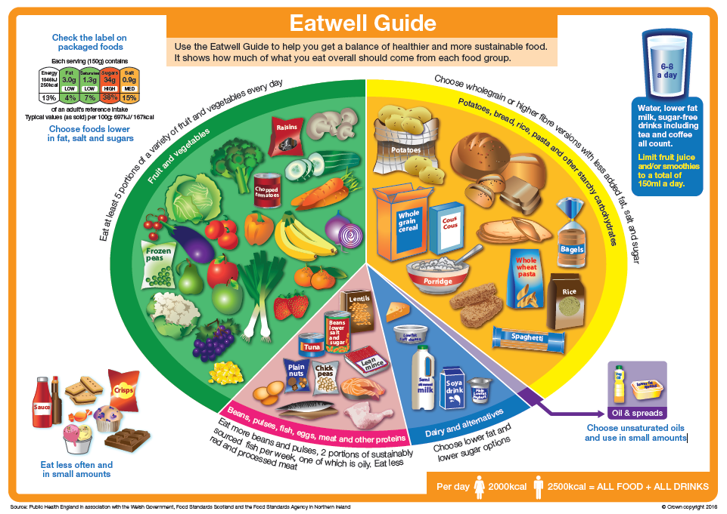

|  |
| --- |
| **Algorithm for Nutrition Care Planning** |

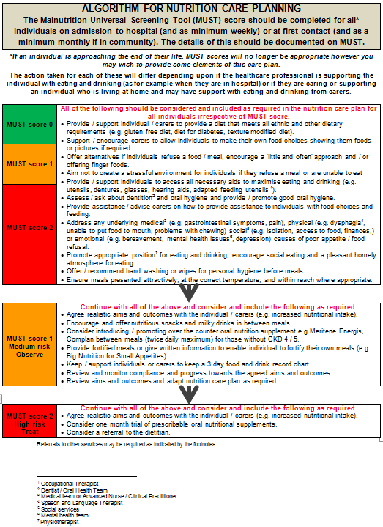

|  |
| --- |
| **Texture Modified Diet, Fluids and IDDSI** |

The new IDDSI criteria have been phased in which has meant that, hospitals and food manufacturers have had to comply with the new criteria since April 2019. As different organisations have had to move over at different times, you may have seen different printed information which contains old and new information on texture modified diet and fluids. The new IDDSI descriptors can be seen below:

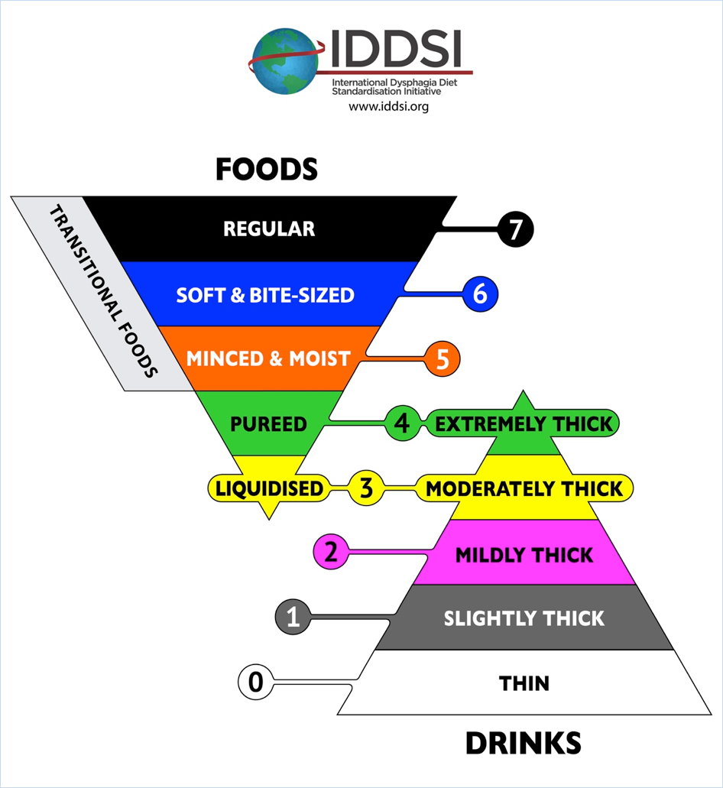

Previously known as stage 3

Previously known as stage 2

Previously known as stage 1

Previously known as naturally thick fluids

‘Normal’ fluids

You may have noticed that thickener products such as Nutilis Clear have already moved over to the IDDSI criteria for thickening. For this, they have had to make some changes to the scoop sizes; therefore it is **important not to use old thickener scoops** with the new IDDSI criteria as you will be giving the wrong amount of thickener which is a potential risk. The following table gives you guidance regarding the difference between the old stages and new levels:

|  |  |  |  |
| --- | --- | --- | --- |
| **IDDSI Level of Thickness** | **Previous**  **Stage of Thickness** | **Number of Scoops for Nutilis Clear** | **Number of Scoops f or Thick & Easy Clear** |
| 1 | - | 1 | 1 |
| 2 | 1 | 2 | 2 |
| 3 | 2 | 3 | 3 |
| 4 | 3 | 7 | 6 |

The Speech and Language Department at Chesterfield Royal have put together a helpful video to demonstrate how the IDDSI descriptors should be mixed and how to make them more enjoyable. It can be found at: <https://www.youtube.com/watch?v=hzdXykWPrXE>

or search YouTube for ‘ Chesterfield Royal Hospital How to Thicken Fluids’



Food also has new IDDSI descriptors which can be seen below:

|  |  |  |  |
| --- | --- | --- | --- |
| **Descriptor** | **Description** | **Testing Thickness** | |
| 0 - Thin | * Flows like water * Fast flow * Can drink through any straw, spout, as is appropriate for the person | Test liquid flows through a 10ml slip tip syringe completely within 10 seconds, leaving no residue | |
| 1 – Slightly Thick | * Thicker than water * Requires a little more effort to drink than thin liquids * Flows through a straw | Test liquid flows through a 10ml slip tip syringe leaving 1-4ml in the syringe after 10 seconds | |
| 2 – Mildly Thick | * Flows off a spoon * Sippable, pours quickly from a spoon, but slower than thin drinks * Effort required to drink through a straw | Test liquid flows through a 10ml slip tip syringe leaving 4-8ml in the syringe after 10 seconds | |
| 3 – Liquidised / Moderately Thick | * Can be drunk from a cup * Some effort is required to suck through a straw * Can’t be piped, layered or moulded on a plate * Can’t be eaten with a fork as will drip slowly through the prongs in dollops * Can be eaten with a spoon * No oral processing or chewing required * Smooth texture with no bits (lumps, fibres, husk, gristle etc.) | Test liquid flows through a 10ml slip tip syringe leaving >8ml in the syringe after 10 seconds  Or  Drips through prongs of a fork in dollops and spreads out on a flat surface | |
| 4 – Pureed / Extremely Thick | * Usually eaten with a spoon but a fork is possible * Can’t be drunk from a cup * Can’t be sucked through a straw * Does not require chewing * Can be piped, layered or moulded * Slow movement under gravity but can’t be poured * Falls of spoon in a single spoonful and holds shape * No lumps * Not sticky * Liquid must not separate from the solid | The prongs of a fork can make a clear pattern in the surface which is retained  +  No lumps | |
| 5 – Minced & Moist | * Can be eaten with a fork or spoon * Could be eaten with chopsticks in some cases * Can be scooped and shaped * Soft and moist with no separate liquids * Lump size 4mm * Lumps are easy to squash with the tongue | When pressed with a fork, the particles should easily be separated and come through the prongs  +  Can be easily mashed with little pressure from the fork | |
| 6 – Soft & Bite Sized | * Can be eaten be a spoon or fork * Can be mashed / broken down with pressure from a fork or spoon * A knife is not required to cut this food * Chewing is required before swallowing * Soft, tender and moist throughout, but no separate thin liquid * Bite sized pieces for adults 15mm / 1.5cm | Pressure from a fork held on its side can be used to cut or break this texture into smaller pieces. If one of the lumps are pressed with enough force to turn a thumb nail white, the lump changes shape and doesn’t return to its original shape. | |
| 7 – Regular | * Normal everyday foods of various textures that are appropriate for the person * Any method may be used to eat these foods * Food may be hard, crunchy or naturally soft * Includes hard, tough, chewy, fibrous, stringy, dry, crisp, crunchy or crumbly bits * Includes dual texture foods | Not Applicable | |
| **BAPEN MUST Tools** | | |
|  | | |

