Clinical system searches for Prioritisation for long term condition reviews in Derbyshire
These initial searches have been shared by the Medicines Optimisation Team to try and support practices in identifying patients to prioritise for review based on the local guide developed by Kriss Owen (K.O. Diabetes lead), Tarun Narula (T.N. CVD lead), Seema Kumari (S.K. Respiratory lead) and Sohrab Panday (S.P. Mental Health lead).
(Please note that while the medicines optimisation team have supported with the searches we were not involved in decisions about the prioritisation of patients).
These first searches aim to show the High priority “red” patients - described as those who need review now as a priority, even during the pandemic.

The searches are based on QoF registers (where applicable), readcoding and medication issues/repeat templates. We have tried to be specific in detailing the cohorts of patients they capture whilst avoiding duplication where possible. There will by default be some cross over of patients in the searches e.g. those in search 05 by reason of CVD will also appear in search 04.
As with all searches we cannot guarantee these are 100% accurate. Their use is optional, but we hope they will prove useful to practices.
Where to find the searches in SystmOne (EMIS instructions to follow)
Select reporting, then clinical reporting and locate the CCG MOD Team folder. A sub- folder titled “Long Term Conditions” has been set up. The High Priority RED Group searches can be found here as per screenshot below:

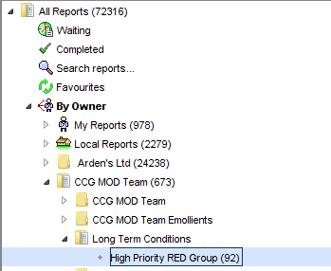

This will then display a suite of searches to run as per next screenshot. (More than these 11 searches will be displayed but it is only these 11 searches that the practice should need, to identify the patients for review):
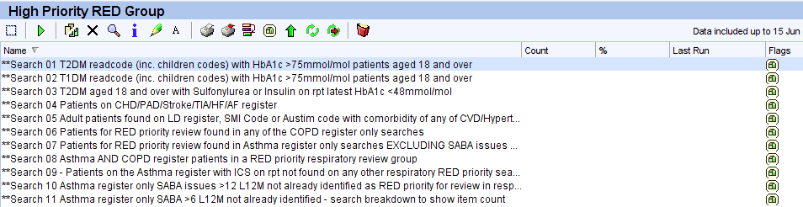
(To run the searches click the first icon to select all and then the second icon to run. A question will pop up asking “Are you sure you want to run all 92 reports?” Click “Yes” to this and the reports will run).
Search detail
DIABETES

- Search 01 Type 2 DM with Hba1c above 75mmol/mol
Search comprises readcode (including children codes) for Type 2 diabetes mellitus joined with most recent HbA1c>75mmol/mol.
This is for patients aged 18 and over as requested by K.O. (current age >17 years)

- Search 02 Type 1 DM with Hba1c above 75mmol/mol
Search comprises readcode (including children codes) for Type 1 diabetes mellitus joined with most recent HbA1c >75mmol/mol.
This is for patients aged 18 and over as requested by K.O. (current age >17 years)

The Type 1 DM patients documented for review were those usually seen by the practice. This could not reliably be determined by searches so practices will need to review these patients to identify whether usually seen by specialist/secondary care teams or the practice.
N.B. A small number of patients may also have both Type 1 and Type 2 diabetes readcodes and appear in both search 01 and 02.

- Search 03 Type 2 DM on insulin or sulphonylurea with HbA1c<48 (high risk of hypos)
This is for patients aged 18 and over as requested by K.O.(current age >17 years)

Search comprises readcode (including children codes) for Type 2 diabetes mellitus combined with a sulphonylurea and/or insulin on repeat joined with most recent HbA1c 48mmol/mol.

CVD

- Search 04 Patients on register for CHD, PAD, Stroke, TIA, Atrial Fibrillation or Heart Failure
Search comprises joined searches for STIA001 Stroke/TIA Register, PAD001 Register, CHD001 CHD register, AF001 Register (most recent match of Atrial Fibrillation codes without having a more recent Atrial Fibrillation resolved code) and HF001 register for Heart Failure. The result is patients found on any of these reports.

MENTAL HEALTH
- Search 05 Adult patients on serious mental illness (SMI) or learning disability (LD)/autism registers with comorbidities (CVD/diabetes/asthma/COPD/poorly controlled hypertension)
Search comprises an existing system wide search for Serious Mental Illness code (which reports on the most recent match of read codes in a cluster of Mental Health: Psychosis, Schizophrenia and Bipolar effective disease codes), combined with LD003 register, and a search for autism read codes. As requested this is restricted to a demographic of over 17 years to show adult patients only.
These patients are then joined with a combined search for CVD (based on CHD, PAD, HF, AF, Stroke and TIA registers), Type 1 and Type 2 diabetes readcodes, Asthma and COPD registers and Hypertension diagnosis code (N.B. poorly controlled hypertension has not been determined it is anyone with a hypertension diagnosis code recorded).
RESPIRATORY
COPD register used is COPD001 (which reports on the most recent match of read codes in a cluster for COPD codes without having a more recent COPD resolved code).
The Asthma register used is AST001 (which reports on the most recent match of read codes in a cluster of Asthma diagnosis codes without having a more recent Asthma resolved code). This register excludes patients with asthma who have been prescribed no asthma related drugs in the preceding 12 months.

- Search 06 Patients for RED priority review in COPD register only searches
It is patients found in COPD001 but not in AST001.
This search is combined individually with a search for each of:
- MRC dyspnoea scale 4/5 reports on most recent match of read code for MRC breathlessness scale 4 or 5 without having a more recent readcode for MRC Breathlessness Scale: grade 1, 2 or 3.
- On triple therapy based on a joined report for ICS/LAMA combination plus LAMA AND LAMA/LABA combination plus ICS AND LAMA+LABA+ICS.
- >2 exacerbation in last 12 months requiring steroids and/or antibiotics this search identifies >2 issues in the last 12 months (a relative search so L12M from whenever the search is ran) of oral Prednisolone and/or oral issues of the antibiotics indicated for an acute exacerbation of COPD as described by NICE/PHE – these are Amoxicillin, Clarithromycin, Co-Amoxiclav, Co-Trimoxazole, Doxycycline and Levofloxacin. This search will by default pick up some issues not necessarily indicated for an exacerbation.
- COPD hospital admission in last 12 months search does not determine reason for hospital admission i.e. whether COPD related or not. It is based on a readcode for Hospital admission in the last 12 months. Again this is a relative search based on 12 months from the date whenever the search is run.
- FEV1 < 50% predicted based on a search for most recent reading of Percent predicted FEV1 without having a more recent Percent Predicted FEV1 >50%.
- Suspected or confirmed COVID19 with or without exacerbations based on a search for the following readcodes (including children): COVID-19 confirmed by laboratory test, COVID-19 confirmed using clinical diagnostic criteria, Suspected COVID-19.

Search 06 is then these individual searches combined to show patients found in one or more.

- Search 07 Patients for RED priority review found in Asthma register only searches

It is patients found in AST001 but not in COPD001.

This search is then combined individually with a search for each of:
- High dose inhaled steroids (>800mcg budesonide total per day or equivalent) based on a search for a current repeat template for ICS devices that at standard dosing would be categorised as high dose as per the guide table on page 6 of the local Asthma in adults guideline. http://www.derbyshiremedicinesmanagement.nhs.uk/assets/Clinical_Guidelines/Formulary_by_BNF_chapter_prescribing_guidelines/BNF_chapter_3/Adult_Asthma.pdf
There will possibly be a few anomalies for non-standard dosing e.g. if only prescribed once daily dosing.
- MART +LTRA +/- Theophylline this search comprises patients with a current repeat template of a drug in the action group Leukotriene receptor antagonists AND a current repeat of any of the four LABA/ICS devices whose license covers MART/SMART usage (as per local asthma guideline) i.e. Fostair 100/6, Fobumix 80/4.5 & 160/4.5, Symbicort 100/6 & 200/6 (turbohaler only) and Duoresp 160/4.5. Search based on generic and brand. As it is +/- Theophylline this has not been included in the search. Please note this search identifies devices licensed for use as MART/SMART, but does not determine they are being used as maintenance and reliever therapy in these patients.
- > 2 exacerbations in last 12 months; this search identifies >2 issues in the last 12 months (a relative search so L12M from whenever the search is ran) of oral Prednisolone and/or oral issues of the antibiotics indicated for a chest infection as described by NICE/PHE – these are Amoxicillin, Clarithromycin, Doxycycline, and Erythromycin and also includes Co-Amoxiclav as requested by S.K. This search will by default pick up some issues not necessarily indicated for an exacerbation. The cohort of patients with Prednisolone >5mg daily for >6 weeks were also identified as high risk and will fall into this search criteria.
- Suspected or confirmed Covid 19 with or without any exacerbations; based on a search for the following readcodes (including children): COVID-19 confirmed by laboratory test, COVID-19 confirmed using clinical diagnostic criteria, Suspected COVID-19.
- Any previous ITU admission search based on read code ever for any general ITU associated readcode and respiratory specific readcodes.
Search 07 is then these individual searches combined to show patients found in one or more.

- Search 08 Asthma AND COPD register patients in a RED priority respiratory review group
It is patients found in AST001 AND COPD001 as the basis for the search. All the 6 COPD register only searches and 5 Asthma only searches (as above) are then joined with this to show anyone on the COPD and Asthma register who falls into one or more of the red priority respiratory review groups.
There are 3 further searches to identify further cohorts of Asthma patients not already picked up in searches 06, 07 or 08.
- Search 09 Patients on the Asthma register with ICS on repeat not found in any other respiratory RED priority search.
The purpose of this search is to identify any patient on the asthma register that is prescribed a dose of ICS that would equate to “high dose” through the number of doses prescribed rather than the actual product being classed as a “high dose” ICS e.g. Symbicort 200/6 3puffs bd. All patients that have already been identified in a “red” respiratory search have been excluded. Although the number of patients in this search may appear high the number of patients requiring review should be low.
To identify who falls into the “red” review criteria an output needs to be applied. To do this right click on search 09 to show patients ( symbol).
Then go to Select Output:
Move the selection to Pre-defined report output and select LTC RED ICS Dose (see next screenshot):
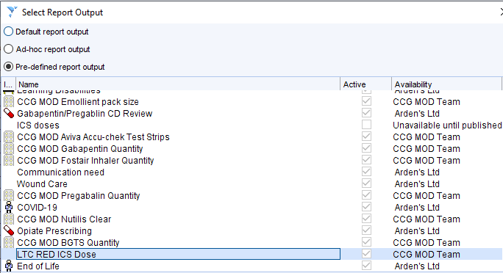
Then click OK and the information will reload with the output applied.
N.B.When you have finished with this you need to return to Default report output (you can reapply the output to the search again if needed).
You should now have a list of patient details as well as the prescribed ICS and dose. This list needs to be filtered to identify anyone prescribed their ICS at a dose that would be classed as “high-dose” (again as per the guide table on page 6 of the local Asthma in adults guideline). http://www.derbyshiremedicinesmanagement.nhs.uk/assets/Clinical_Guidelines/Formulary_by_BNF_chapter_prescribing_guidelines/BNF_chapter_3/Adult_Asthma.pdf
This list of patients can be reorganised by product or dose by clicking on the header of each column – this should speed up filtering through this list. An example of what we are looking for is in the screenshot below:
Please ask a member of your usual Medicines Optimisation Team to support with applying this output if needed but it is a practice’s responsibility to identify the patients for review.
**Reminder: Reset the output to default report output when finished**
The final cohort of asthma patients for red priority review is >12 SABA inhaler prescriptions in the previous 12 months. Due to variation in the quantities on each prescription this has been divided into two searches as follows:
- Search 10 Patients on the Asthma register only (i.e. excludes those also on the COPD register) having had ≥12 issues of a SABA prescription in the last 12 months (relative search so 12months from whenever search is run) regardless of number of inhalers on each issue – all identified patients in this search fall into the RED priority criteria.
- Search 11 Patients on the Asthma register only (i.e. excludes those also on the COPD register) having had ≥6 issues but less than 12 issues of a SABA prescription in the last 12 months (relative search so 12months from whenever search is run).
A breakdown of the results for this search will aid review. Right click over search 11 and this time choose the second option down “breakdown results”. This should give you the following screen:
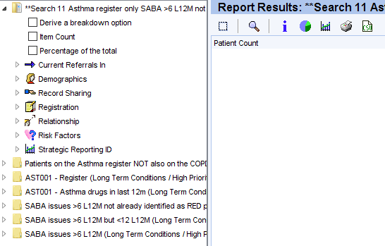
Click on the little triangle to the left of the bottom file (SABA issues ≥6 L12M):
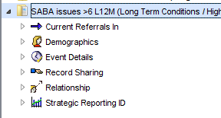
Then the little triangle to the left of Event Detail and click on the Event Count box to put a tick in it:
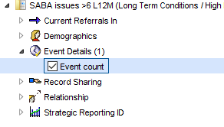
If you then refresh the search and show the patients, those with the higher number of issues will be more likely to have had ≥12 inhalers issued in the L12M. Start with those at item count of 11, 10, 9 etc.
Click here to refresh

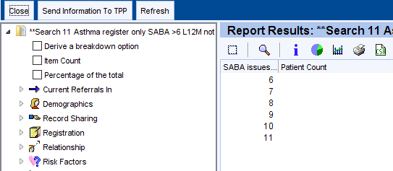

Then here to show the patients

Responsibility for implementing the guidance and the care of individual patients lies with each GP practice but if you have any specific queries in regards to the searches then please contact a member of your usual Medicines Optimisation Team.

