Communications plan for learning disability week - 15-22 June
Background

Mencap’s annual celebration of learning disability is this year focused on friendships during lockdown. Due to the coronavirus pandemic, we are all currently living in lockdown. This means that many people with a learning disability are feeling isolated, as they are unable to see their friends and families.

We know that people with a learning disability already experience high levels of loneliness and social isolation and that this will only have been made worse by the lockdown.

We want to show the importance of friendships to help with tackling isolation, as well as exploring the different ways of maintaining friendships during this unusual time.

Key messages

- Using technology like Zoom, WhatsApp and MS Teams can help people keep in touch.
- During lockdown people with a learning disability can maintain friendships, join in with things and do things they enjoy.
- Having an active social life can help people with a learning disability to feel happier, included and valued.
- Being part of a supportive work team is helping people with a learning disability during lockdown.
- The NHS is still here to look after you if you have a medical condition or injury which needs treatment.

NHS England and NHS Improvement resources
Films hosted by Learning Disability England
We have commissioned Ace Anglia and Speak Up to produce four films each to promote the resilience of people with a learning disability and how they have used friendships to adapt to the new normal during the pandemic.
The films will be two minutes in length each but with links to longer films if available. Each film will be recorded on Zoom and jointly branding by NHS England and NHS Improvement and Learning Disability England.
Technology helps Mark keep in touch
Mark talks about how technology has helped him keep in touch with his girlfriend during lockdown, they’ve been watching films and joining in yoga and dancing sessions together.
Different ways of coping during lockdown
Patrick talks about how he has coped with life in lockdown and his mum Jenny talks about how she is learning to use technology to support herself and Patrick.
Allotment helping people during lockdown
The Speak Up allotment is helping people to spend time outdoors with their friends during lockdown, learning new skills and experimenting with growing their own food.
Quizzes, beauty sessions and yoga keeping people busy during lockdown
Alison talks about how daily zoom meetings make sure everyone stays in touch and have what they need. Weekly quizzes, beauty sessions and yoga are helping everyone stay well.
Technology is helping people stay safe and in touch during lockdown
Vicky describes how frequent Zoom meetings for workers and volunteers are making sure people are keeping safe, have food in the house and don’t feel like they are on their own during lockdown.
Supporting each other during lockdown
Steven talks about how having a good friend is helping them both during lockdown. Talking to each other about how they feel and giving each other advice.
Having people to talk to about feelings really helps
James talks about how a lockdown programme and wellbeing groups have helped him to cope with life during coronavirus. Regular calls to his family, support workers and learning disability nurse have meant that he always has someone to talk to about his feelings.
NHS England and NHS Improvement films (PAC approval 001559)
Two short films with people with a learning disability who are employed by NHSEI talking about their experiences of working through lockdown and how work relationships have enabled them to be supported while working at home. Roger Banks, National Clinical Director of Learning Disability and Autism will talk about the importance of friendships and work relationships from a clinical perspective.
Work friendships help increase our confidence and helps reduce stress and anxiety
This learning disability week Roger Banks, National Clinical Director for the learning disability and autism programme and Karl Butler, Learning Disability Adviser talk about the importance of good working relationships and friendships at work.
Working during lockdown helps keep a sense of purpose and routine
This learning disability week Carl Shaw and David Gill, Learning Disability Advisers talk about how working in a supportive team of people from different backgrounds has helped them to share their feelings whilst keeping a sense of purpose.
Katie’s poem
We are developing some social media cards with these poems written by Katie Matthews, Learning Disability network manager at NHS England and Aaron Wood, Lived Experience Expert Lead for Autism.
We’ll beat this
There's a time, when we all need,
To either quit or follow through.
Just lose hope, or trust your heart,
To get us through the dark.
Without the one, who needs help to carry on.
We might get lonely, but we're not alone
Together, we’ll beat this
We make each other stronger, and
That ain't never gonna change
At times we may just feel like our backs are to the wall
We hold our heads up high
And keep standin' tall
We know that our backs are covered
Because we have each other
And were down for whatever
If you hear me throw your hands up
If you know that you’re a star
You better stand up if you know just who you are
Never give up, Never stay down
Together, we will beat this because
We make each other stronger, and
That ain't never gonna change
Sometimes life may get you down
But you better hold your ground
Can't nobody live your life but you
Just stay true to who you are,
and follow your heart
Your heart, your heart
If you know that you’re a star
You better stand up if you know just who you are
Never give up, Never stay down
Together, we’ll beat this
We make each other stronger, and
That ain't never gonna change

Aaron’s poem

Here I am laying alone in the dark
12 week of self-shielding I’ve began to lose my spark
I am not allowed to see family and friends
I can’t wait till covid19 ends

I have forgotten what it is like to be the Aaron everyone knows and loves
It makes me feel uneasy seeing everyone on public transport wearing masks and gloves
There is so many people I want to cuddle and see
Happy is how I want to be

Am done with crying every night
I feel alone and isolated have a drink I might
There’s been so many autistic lives taken during this time
Being locked away in my one roomed studio flat makes me feel like a prisoner
Who’s locked up for his crime

I just want to be going to work and live life how I used to do
When the prime minster extended the lock down by three week that’s more time
Of me feeling alone and blue
There’s only a few family and friends who have reached out for me
Please all the people having parties during lockdown stop being so selfish that is plea
Covid19 made my best friend so ill
I prayed for you every night Rebecca saying beating covid19 you will
There are so many people who are vulnerable to get the virus just like me
When the pandemic ends happy as Larry I will be

Picture by David Gill, Learning disability and autism adviser for children and young people

David has drawn a picture of the current team of people with lived experience which can be shared on social media channels to celebrate the five year anniversary of employing people on the programme.

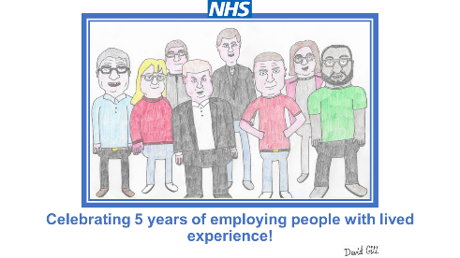

Social media

See separate social media plan with schedule of posts. These slides are available to share across platforms.
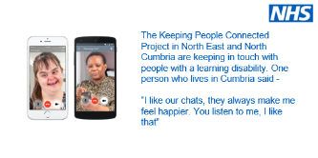
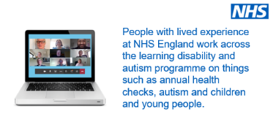
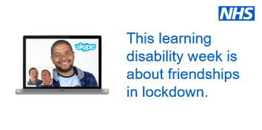
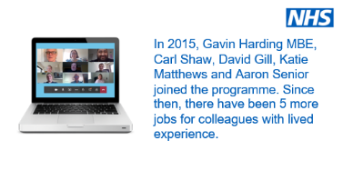
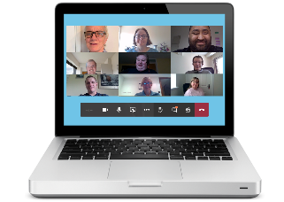

To support and retweet

@DavidHarling1
Ahead of learning disability awareness week, here's a taster in readiness, of what we plan will be a flurry of 'Postcards from the Brightside', which feature Real nurses - Real lives. Celebrating and Promoting learning disability nursing! Get ready... https://t.co/L7J5V7VvaE

The Reasonable Adjustment Flag – new webpage published

The Reasonable Adjustment Flag is a national record which indicates a person needs reasonable adjustments to support them in accessing NHS services. Having been successfully piloted, the capability is now in further final development, and will be available for wider utilisation from the end of 2020. The new web page includes the benefits of the flag, case studies and next steps.

Other resources to link to
Title | Link | Format
Staying in touch

How to use zoom | www.aceanglia.com/wp-content/uploads/2020/03/how-to-use-zoom-easyread-3-1.pdf | Easy read
Connecting people | www.learningdisabilityengland.org.uk/what-we-do/keeping-informed-and-in-touch-during-coronavirus/connecting-people-including-webinars/ Learning Disability England connecting people webpages | Web pages
Zoom tutorial | www.youtube.com/watch?v=zhBd30l1prg | Video
Guide to using MS Teams | www.learningdisabilityengland.org.uk/wp-content/uploads/2020/03/how-to-use-microsoft-teams-guide-final.pdf | Easy read
WhatsApp | www.learningdisabilityengland.org.uk/wp-content/uploads/2020/03/whatsapp-an-easy-read-guide-DRAFT-v2.0.pdf | Easy read
We’ll meet again | Act Up!'s version of We'll Meet Again with commentary from the act uppers  www.youtube.com/watch?v=Dt7S3L-4R4E | Video
Poem about isolatation | Being together on the computer instead of in real life  www.youtube.com/watch?v=XaIiako9AVk | Video
Friendships

Friendships and having a social life | www.mencap.org.uk/about-us/what-we-think/friendships-what-we-think | Plain English
Friendships and having a social life | www.mencap.org.uk/sites/default/files/2016-09/Friendships%20and%20Social%20Life%20-%20%20easy%20read%20final.doc | Easy read
Friend or fake – hate and mate crime | https://arcuk.org.uk/safetynet/files/2012/08/Friend-or-Fake-Booklet.pdf | Easy read
Relationships | www.peoplefirstinfo.org.uk/health-and-well-being/easy-read-information-for-people-with-learning-disabilities/relationships/ | Easy read
Keeping busy

Free online concerts and music | www.facebook.com/coronavirusfest/?__tn__=K-R&eid=ARA8bt8SfMcDISLXpiCUSdWve7Y0NowQLKnb894b7ds3YpW8ZO6DjBHlOJzbZgt0aqxV_z-f6kh02tys&fref=mentions | Webpages
Chat and a brew | https://paradigm-uk.org/2020/03/20/the-gr8-chat-brew/ Great Chat & Brew webpages | Webpages
Dance classes | https://dancesyndrome.co.uk/online-dance-sessions/ DanceSyndrome online dance classes | Webpages
Creative arts | www.actupnewham.co.uk/time-capsule | Webpages
 | Staying safe during lockdown
Social bubbles | /www.keepsafe.org.uk/posters?fbclid=IwAR3Sgq664udSUGwG8wYyuBN38bF7AtHFujGEAeTF94Dzqa0Dp640_SIsjbc | Poster
 | Accessing NHS services
NHS services | Getting NHS help when you need it during the coronavirus outbreak | Plain English
NHS services | Getting NHS help when you need it during the coronavirus outbreak | Easy read

