Screening & Immunisation Team (SIT) Update
w/c 26 May 2020

Please cascade to ALL staff, including GPs, Practice Nurses & Reception Staff

COVID-19 Guidance:
Current COVID-19 guidance for clinical and non-clinical environments is available here:

- https://www.gov.uk/government/collections/wuhan-novel-coronavirus
- https://www.gov.uk/coronavirus

Screening Programme Update:
- The routine Diabetic Eye Screening (DES) programme has paused, but high risk and pregnant women are still being called for appointments.
- The Antenatal and Newborn (ANNB) screening programme continues as normal.
- The routine Breast Cancer Screening programme has paused, but Trusts have been guided to ensure screening of high risk women continues.
- The Cervical Screening programme continues. Colp clinics continue, but at a reduced capacity with High risk referrals seen as usual and low risk referrals contacted by the individual colposcopy clinics.
- The Bowel Cancer Screening programme has paused, but work is currently underway to invite individuals with an abnormal FIT test result (presently paused in the pathway) for further investigations i.e. colonoscopy. Covid-19 restrictions and risks to be considered for each individual.
- The Abdominal Aortic Aneurysm (AAA) programme has paused, and services are now planning how to restore the programme, initially prioritising those at higher risk i.e. surveillance patients.

Immunisation Information

Annual Seasonal Flu Letter 2020/2021 – published 14.05.20

The annual flu letter for 2020/21 was published on 14.05.20. This is the first of two letters to be published in 2020/21.

The first letter confirms current eligibility for the flu vaccine and recommendations on which vaccines to offer to different patient groups. It encourages providers to start planning now for the 2020/21 seasonal flu delivery and for practices to assure themselves that they have ordered sufficient vaccine.

A second seasonal flu letter will be published nearer to the start of the vaccination programme, with details about any potential expansion to the programme and guidance on how to manage the programme given the impact of COVID-19.

https://www.gov.uk/government/publications/national-flu-immunisation-programme-plan

NHS Resources to encourage people to attend Routine Vaccinations

These immunisation social media cards can be downloaded from the Health Publications website using the product code 2020058;
https://www.healthpublications.gov.uk/ViewArticle.html?sp=Scovid19promotingimmunisationsocialmediacards
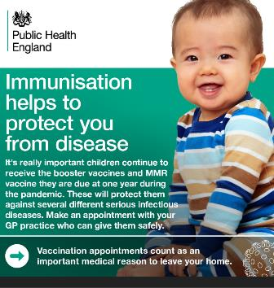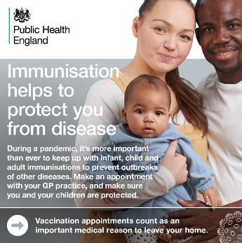

Vaccine update: issue 307, May 2020
Vaccine update: issue 308, May 2020
The May issue features:
- MMR Oral Fluid Home Kit video and guidance
- new! immunisation social media cards
- National flu immunisation programme plan
- Pneumococcal outbreaks guidance
- PCV13 schedule change reminder
- 2019 to 2020 Inactivated flu vaccine for children – still available to order
- Maternal Pertussis programme – Change to dTaP/IPV vaccine
- update to Bexsero Patient Information Leaflet
- MMR vaccine ordering
- The EU Falsified Medicines Directive (FMD) and Delegated Regulation as applicable to PHE supplied vaccines for the national immunisation programme
- early notice: May bank holiday delivery and order cut-off changes
- registering for a new or updating your existing ImmForm vaccine ordering account

Vaccine update: issue 307, April 2020

Vaccine update: issue 307, April 2020

The April edition features:

- European and World Immunization Week: Immunizations protect you from disease
- maintaining immunisation services during the COVID19 pandemic to reduce the serious risk of vaccine-preventable disease
- managing locally held vaccine stock in primary care
- school-age immunisation programmes
- immunisations offered as part of antenatal or post-natal care
- conquering a new enemy: how soldiers are helping the fight against COVID-19
- Pneumococcal Polysaccharide Vaccine (PPV) & PCV13 schedule change reminder
- Flu vaccine supply for the 2019 to 2020 children’s flu programme
- maternal Pertussis programme – Change to dTaP/IPV vaccine
- update to Bexsero Patient Information Leaflet
- MMR vaccine ordering
- The EU Falsified Medicines Directive (FMD) and Delegated Regulation as applicable to PHE supplied vaccines for the national immunisation programme
- early notice: May bank holidays delivery and order cut-off changes
- registering for a new or updating your existing ImmForm vaccine ordering account

Paracetamol for MenB immunisation – currently out of stock

A small quantity of paracetamol 120mg/5ml sachets to support the routine MenB immunisation programme was available to order by contacting the ImmForm Helpdesk helpdesk@immform.org.uk quoting your account number. Any updates on further availability of this product will be posted on https://portal.immform.dh.gov.uk/Home.aspx so please check ImmForm regularly.

There was a limited volume short-term central supply which was obtained following reports of possible variation in the availability of infant paracetamol on sale to the public during the COVID-19 pandemic.

A single sachet of infant paracetamol 120mg/5ml suspension may be supplied, or 2.5ml administered, to infants who have been unable to obtain a supply of paracetamol suspension prior to attending for primary MenB immunisation.

Parents/carers will need to purchase a home supply of infant paracetamol 120mg/5ml suspension for the subsequent recommended doses.

A leaflet and protocol to support the supply and administration of infant paracetamol by immunisers can be found at: https://www.gov.uk/government/publications/menb-vaccine-and-paracetamol.

Contact details for the Screening & Immunisation Team:

Name | Programme | e-mail | Telephone number
Sarah Mayfield (SIM) | ANNB Screening, DES, Child & Adolescent Immunisations | sarahmayfield@nhs.net | 07918368418
Annie Tasker (SIM) | Bowel, AAA, Breast & Cervical Screening, Adult Immunisations & Seasonal Flu | annie.tasker@nhs.net | 07860180484
Sarah Bolstridge (SIC) | Bowel & AAA Screening | sarah.bolstridge@nhs.net | 07876 851804
Gemma Riley (SIC) | Breast Screening, Adult Immunisations & Seasonal Flu | gemma.riley4@nhs.net | 07730371163
Alison  Campbell (SIC) | Child & Adolescent Immunisations | alison.campbell@nhs.net | 07721231702
Tania  Murdoch (SIC) | Cervical Screening | tania.murdoch@nhs.net | 07730391691
Hayley Billings (SIC) | ANNB (Derbys), Child & Adolescent Immunisations | hayley.billings@nhs.net | 07860179039
Zoe Scott (SIC) | DES & SFHFT ANNB | zoe.scott@nhs.net | 07713796041

Alternatively you can email the generic email account:

ENGLAND.SCRIMMS@nhs.net

This information can be made available in alternative formats, such as easy read or large print, and may be available in alternative languages, upon request. Please contact the NHS England & NHS Improvement - Midlands Screening and Immunisation Team by email to england.denosit@nhs.net

