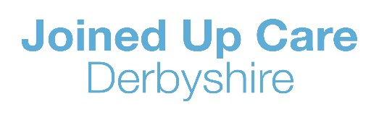
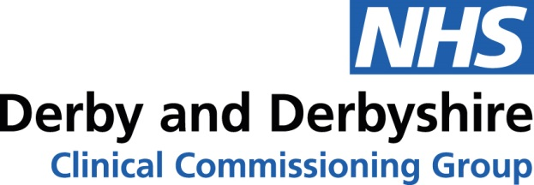

Mental Health and Wellbeing Support for Children, Young People, Parents and Carers during the Covid-19 Pandemic

We know that the closure of schools due to the Covid-19 pandemic has the potential to be an anxious and uncertain time for children, young people, parents and carers across Derby and Derbyshire. We are pleased to be able to offer the following services to support the whole family. Please share these with your colleagues.
Mental Health Support Line
A new mental health support line run by Derbyshire Healthcare Foundation Trust and operating seven days a week between the hours of 9am and midnight has been set up to provide access to support for people of all ages in Derby and Derbyshire. Please call number 0300 790 0596 where mental health professionals will be on hand to advise, there may be a low cost charge for this. For more information, please visit:
https://www.derbyshirehealthcareft.nhs.uk/getting-help/coronavirus-covid-19/mental-health-support-line

Childrens Adolescent Mental Health Services (CAMHS)
There are two main CAMHS services in Derby and Derbyshire; one is run by Chesterfield Royal Hospital in North Derbyshire and the other by Derbyshire Healthcare Foundation Trust in Derby City and South Derbyshire.

North Derbyshire CAMHS Service:

Website: www.camhsnorthderbyshire.nhs.uk

How to refer: https://www.camhsnorthderbyshire.nhs.uk/how-to-refer

South Derbyshire and Derby City CAMHS Service:

Website: www.derbyshirehealthcareft.nhs.uk/services/childrens-mental-health-services-camhs-derby-and-southern-derbyshire

How to refer: https://www.derbyshirehealthcareft.nhs.uk/services/childrens-mental-health-services-camhs-derby-and-southern-derbyshire/im-professional/single-point-access-referral-form

CAMHS Specialist Community Advisors:

Specialist Community Advisors (SCAs) provide consultations to all professionals from statutory, community and voluntary organisations about the Mental Health and well-being of child or young person. Each locality within Derbyshire has a dedicated Specialist Community Adviser. See below for their contact details.

AREA | NAME | Tel No | Email address
Erewash North & South | Amanda Selby,  Clinical Lead | 07768 671397 | amanda.selby1@nhs.net
Southern Derbyshire | Dawn Wain | 07717 782268 | Dawn.wain@nhs.net
Amber Valley & South Dales | Rachael McIlwrick | 07917 243130 | Rachael.mcilwrick@nhs.net
Derby City locality 1,2 & 5 | Sonia Simpson-Brown | 07833 927241 | Sonia.simpson-brown@nhs.net
Erewash and Southern Derbyshire | Angela Jordan | 07787 274992 | angela.jordan6@nhs.net
Amber Valley and City locality 3&4 | Miriam Krepa | 07717 538764 | Miriam.krepa@nhs.net
High Peak and North Dales | Sam Jones, Team Lead North | 07900 243 578 | samantha.jones27@nhs.net
Chesterfield South & Central: | Liz Stephens | 07795 354 988 | e.stephens1@nhs.net
Chesterfield Nth, Staveley & Brimington | Natalya Van Steenbergen | 07766 697 940 | natalya.vansteenbergen@nhs.net
Bolsover and North East District: | Sophie Tipple | 07825 995 967 | sophie.tipple@nhs.net
Dronfield, Eckington and Clowne: | Marie North | 07899 962 773 | marienorth@nhs.net

Targeted Intervention Community Triage (TICT) (Low to Moderate Mental Health Needs Support)

An interim service has been set up as a result of Covid-19 to direct referrals to a range of community providers offering additional 1:1 targeted interventions to support children and young people across Derby & Derbyshire with low to moderate level mental health needs at this particularly difficult time.

The interventions, that include 1:1 therapeutic counselling and 1:1 peer support sessions via multi-media platforms, can help children and young people who are experiencing depression, low mood, bereavement, stress, panic or anxiety and aim to enable CYP to cope better and prevent further escalation of issues.

To make a referral please complete the online referral form. An experienced therapist will contact the child, young person or parent to complete a triage assessment and make individualised recommendations and appropriate onward referrals

If you need further guidance about the TICT offer and process, please contact your local CAMHS Specialist Community Adviser.

Non COVID-19 related referrals can continue to be made into the Build Sound Minds service.

Self Help for CYP/Parents/Carers

Derby and Derbyshire Emotional Health & Wellbeing Website:

The Derby and Derbyshire Emotional Health and Wellbeing website is a new website that has been set up and contributed to by key organisations in the area. The website provides a one-stop-shop to find local information about emotional health and wellbeing support and other related information that is available.
Visit: www.derbyandderbyshireemotionalhealthandwellbeing.uk

Online Digital Counselling Support
Children and Young People
The Kooth service provides free, online mental health and wellbeing support from accredited counsellors for 11-25 year olds in Derby and Derbyshire from 12 noon until 10pm on weekdays and 6pm-10pm on weekends. Additionally, the service will provide 24/7 access to online forums where concerns and relevant articles can be shared and discussed. To access Kooth, please visit www.kooth.com and create a free account.
Parents and Carers
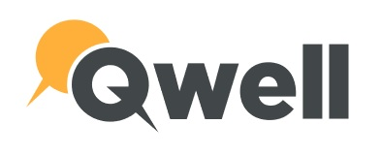
The Qwell service provides free, online mental health and wellbeing support from 12 noon-10pm on weekdays and 6pm-10pm on weekends from accredited counsellors for parents and carers in Derby and Derbyshire whose children are under the age of 18. Additionally, the service provides 24/7 access to online forums where concerns and relevant articles can be shared and discussed.
To access Qwell, please visit www.qwell.io and create a free account.

