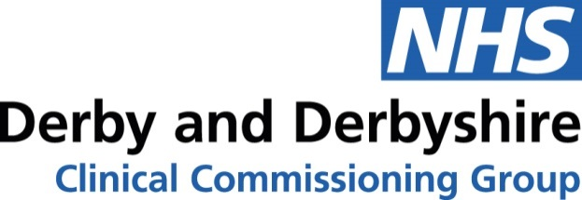

IMPORTANT – NHS Derby and Derbyshire Orthotics Service
Changes to the NHS Orthotics Service provider
As of 1st June 2020 Blatchford will be the sole provider of orthotics across Derbyshire. You can find more about the organisation here https://www.blatchford.co.uk/
The services will be transferred to Blatchford along with the patient records. Records will be transferred in accordance to the UK Data Protection Act 2018.
Commissioners are working with all providers to make sure there is no disruption to the orthotics service for patients and referrers.
What this means for patients
We will be arranging to transfer all referrals and existing patients to Blatchford.
As a result of current pressures in the NHS due to COVID-19 all routine appointments have been temporarily suspended. This will lead to delays in future appointments (see below information about what to do if a patient requires urgent contact with the service).
Blatchford will work through the backlog of appointments and will prioritise urgent cases during this time.
The new service was procured to offer a service that operates in line with national orthotic specifications. After clinical assessment by an Orthotist, this may lead to changes in the provision of orthoses for some patients. Should a patient present with concerns around this they should be directed to PALS so their concerns can be reviewed.
All patients are being contacted by letter to:
- advise of the change in providers
- confirm that there is no need for them to return to their GP
- advise on potential delays due to covid-19 pressures
- advise how to contact the service if there is a problem with their orthoses
- advise on how to seek help, advice, support and information through the PALS service.
Premises
The new hub shall be based at The Derby & Derbyshire Orthotic Service, The Derwent Valley Medical Centre, 18 St Marks Road, Derby DE21 6AH.
This place has on-site parking facilities and is accessible by the following public transport links:
- Easy access from the A52
- 3.8 miles from Derby railway station
- 3.5 miles from Derby bus station
- 100 metres from the bus stop at the junction of St Marks Road and Nottingham Road
Other sites across Derbyshire:
Blatchford will continue to deliver clinics from current DCHS community sites and Chesterfield Royal Hospital. Service users will be given more information on locations and frequency in due course.
UHDB will continue to facilitate limited clinical space for diabetic MDT and paediatric patients.
IMPORTANT – Future referrals
To support ease of referral and minimise any impact on primary care, Blatchford are working with Commissioners to support referral of patients through a referral template that is being modified to support self-population from SystemOne/EMIS. The referral will then need to be emailed to: cabsl.derbyshireorthotics@nhs.net
Allied Health Professions will continue to be able to refer into the service by emailing the referral form to: cabsl.derbyshireorthotics@nhs.net
After 1st June Blatchford can be contacted by phone on: 01332 369400

If you have any further questions or concerns for Commissioners then please contact: us on: ddccg.communications@nhs.net
Thank you,
NHS Derby and Derbyshire Clinical Commissioning Group

