Minor Eye Conditions (MECs) – update 14.5.2020
Distribution: GP Practices, Optometric Practices
Name Change! MECs > CUES

Since piloting the expansion of the MEC pilot to enable GP Practices to signpost patients to Opticians, NHSE/I have issued a Specification for the provision of urgent eye care services for CCGs.

The pathway within Derby & Derbyshire CCG remains unchanged, however for consistency, the service shall now be known as CUES (COVID-19 Urgent Eyecare Service).

Documentation for GP Practices and patients are embedded here however the participating practices and pathway are in the pages below. The number of Opticians participating in this is expanding and we will issue updates in the near future.

How is it going?

270 patients have presented to the service in a 3 week period; weekly numbers ranging from 84-98 during this time and steadily increasing. 199 of these had urgent eye conditions requiring the patient to be assessed within 24 hours.

On triage, 71 issues were deemed to be more routine, and the clinician decided an appointment within 5 days was appropriate.

Of the all appointments offered, only 2 were delayed and this was down to patient choice. Every arranged appointment was attended by the patient; DNA rate for the service is 0%.

Issues are being dealt with remotely by phone/video call assessment wherever this is appropriate, to reduce social contact and the associated risk of COVID-19 spread. In this period, 119 out of the 270 presenting issues were dealt with remotely (44%), with the remaining patients assessed face-to-face with PPE.

The overall discharge/follow up in Community rate is 78% for the service and urgent referrals are at 14%.

Response time on average for urgent symptoms dealt with by remote assessment was 49 minutes. Where a F2F was required, urgent patients were seen, on average, 5 hours 27 minutes from initial presentation.

42 GP practices have referred patients into the service to date.

Red flag - issues for Derbyshire CUES

Some patients with eye issues will have red flag symptoms that require the GP to bypass CUES and refer directly to the Hospital.

This is necessary to avoid delay in treating the most serious sight and life-threatening conditions.

Producing a prescriptive list of red flag symptoms has been avoided, as it is important to ensure that GPs and Optometrists retain their ability to exercise clinical judgment.

However, Derbyshire LOC have convened to create a list of red flag symptoms for Optometrists, GPs, and their respective support staffs, to use as guidance when deciding whether to refer a patient to CUES.

Consider the following as very general rules:
- The more severe the symptoms, bilateral concerns and shorter duration of onset warrants closer review
- Children and elderly should be assessed with a low threshold for review sooner.

Examples of red flag symptoms:

- Acute onset red eye, severe pain, getting worse with time AND reduced vision. Always enquire about contact lens wear if corneal ulcer is suspected.
- Eye trauma in the affected eye:
  - Including severe blunt injuries (sufficient to cause a Hyphaema)
  - Embedded foreign bodies (especially high velocity e.g. hammer and chisel injuries)
  - Penetrating injuries
  - Chemical injuries (make a note of the offending agent where possible).
- ANY Eye surgery, including intra-ocular injections, within past 30 days AND current issue is in this eye (e.g. suspected endophthalmitis).
- Acute problems relating to a previous corneal graft.
- Severe eye pain (enough to cause patient to stop normal daily activities). Very painful eye WITH vision loss AND nausea/vomiting OR haloes around lights AND cloudy cornea, and mid-dilated, non-responsive pupil (i.e. suspect angle closure glaucoma, ACG). NOTE: if bilateral, is VERY UNLIKELY to be acute ACG.
- Droopy eyelid (ptosis) WITH painful eyes or headaches, double vision AND an abnormal pupil:
  - If pupil is large think cerebral aneurysm
  - If pupil is small and the ptosis mild, consider acute Horner’s Syndrome.
- Sudden-onset double vision WITH other neurological signs suggestive of stroke. Check for Hemianopia or Quadrantanopia on gross confrontation.
- Transient or sustained vision loss WITH headaches AND soreness of scalp, pain combing hair, jaw pain when eating (i.e. suspect temporal/giant cell arteritis).
- Swollen eyelid WITH fever or WITH red, painful, bulgy-looking (protruding or proptosed) eye AND double vision or restricted eye movement (i.e. suspect orbital cellulitis).
- Acute painless loss of sight – consider Arterial or Venous occlusions. If so, needs systemic review. If uncontrolled diabetic – consider vitreous haemorrhage from possible proliferative disease.

GP Feedback
Whilst not wanting to add any burden to GPs with questionnaires; feedback as to the service would be extremely beneficial.
Please forward any comments on your experiences of the service to ddccg.optometry@nhs.net

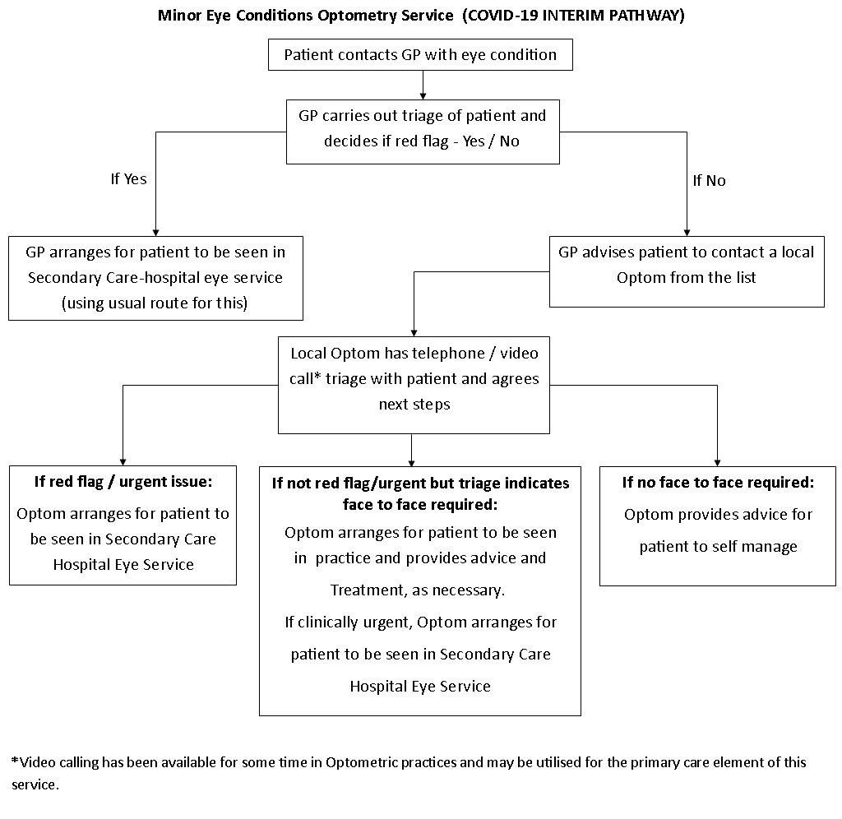
COVID-19 Urgent Eyecare Service (CUES)

Temporary service - COVID-19 response

Information for patients
To assist with the current pressures faced as a result of COVID-19 in GP practices and hospitals, NHS Derby and Derbyshire CCG has put in place a service that enables patients with eye problems to be reviewed by an Optician.

From the information you have provided to your GP Practice, you have been advised to contact one of the Opticians listed below for advice. You can choose any of the Opticians from the list and will be able to arrange a time to speak with them.

The Optician you speak with will be able to provide advice over the telephone or via video call for managing your eye condition. If necessary, they may also arrange to see you face to face with appropriate PPE precautions or, refer you on to other services.

Please see below the list of Opticians, their contact numbers and opening times which will help you make a decision about which to contact.

The Optician will discuss any concerns you may have and respond to your questions.

 |  |  |  |  | Opening Hours
Practice | Address | Town | Post  code | Tel Number | Monday | Tuesday | Wednesday | Thursday | Friday |  | Saturday | Sunday
Chesterfield & Northeast Derbyshire
Chesterfield Specsavers | 2 Burlington Street | Chesterfield | S40 1RR | 01246  222334 | 08:30-17:30 | 08:30-17:30 | 08:30-19:00 | 08:30-19:00 |  | 08:30-17:30 | 09:00-17:30 | 10:00-16:00
Chesterfield Vision Express | Unit 2, 16 Packers Row | Chesterfield | S40 1RB | 01246  277432  08000  3821777 | 09:00-17:30 | 08:45-18:00 | 09:00-17:30 | 08:45-18:00 |  | 09:00-17:30 | 09:00-17:30 | 10:00-16:00
Elliott & Heath | 79 Newbold Road | Chesterfield | S41 7QA | 01246  275847 | 08:30-17:00 | 08:30-17:00 | 08:30-12:00 | 08:30-17:00 |  | 08:30-17:00 | 08:30-12:00 | Closed
Murgatroyd-Holmes | 33 High Street | Staveley | S43 3UU | 01246  477199 | 09:00-17:30 | 09:00-17:30 | 09:00-17:30 | 09:00-17:30 |  | 09:00-17:30 | 09:00-12:00 | Closed
Thomas & Holloway | 33 Chesterfield Road | Dronfield | S18 2XA | 01246  419408 | 09:00-17:30 | 09:00-17:30 | 09:00-20:00 | 09:00-17:30 |  | 09:00-17:30 | 09:00-13:00 | Closed
Matlock Specsavers | 7 Crown Square | Matlock | DE4 3AT | 01629  704000  01246  222334 | 09:00-17:30 | 09:30-17:30 | 09:00-17:30 | 09:00-17:30 |  | 09:00-17:30 | 09:00-17:00 | 10:00-16:00
Hope Valley Opticians | Hathersage Park, 5B Heather Lane | Hathersage | S32 1DP | 01433  659565 | 09:00-17:30 | 09:00-17:30 | 09:00-17:30 | 09:00-19:30 |  | 09:00-17:30 | 09:00-13:00 | Closed
Crystal Peaks Specsavers | Unit 50D, Crystal Peaks Shopping Centre | Mosborough, Sheffield | S20 7PN | 01142  513111 | 08:45-17:30 | 08:45-17:30 | 08:45-17:30 | 08:45-18:30 |  | 08:45-18:30 | 08:45-17:30 | 10:00-16:00
Norton Specsavers | Unit 9A, St James Retail Park, Bochum Parkway | Norton, Sheffield | S8 8BS | 01142  839731 | 09:00-17:30 | 09:00-17:30 | 09:00-19:00 | 09:00-17:30 |  | 09:00-17:30 | 09:00-17:30 | 10:00-16:00
Buxton & Northwest Derbyshire
Buxton Boots | Unit 4, Spring Gardens Shopping Centre | Buxton | SK17 6DE | 01298  22443 | 09:00-17:00 | 09:00-17:00 | 09:00-17:00 | 09:00-17:00 |  | 09:00-17:00 | 09:00-17:00 | Closed
Buxton Specsavers | Unit 14, Spring Gardens Shopping Centre | Buxton | SK17 6DF | 01298  766130 | 09:00-18:00 | 09:00-18:00 | 09:00-18:00 | 09:00-18:00 |  | 09:00-17:30 | 09:00-17:30 | 10:00-16:00
Jenks-Burgess | 24 Market Street | Whaley Bridge | SK23 7LP | 01663  733861  01614  807423 | 09:30-17:30 | 09:00-17:30 | 09:30-12:30 | 09:30-17:30 |  | 09:00-17:30 | 09:00-12:30 | Closed
Morans Opticians | 28 Market Street | New Mills | SK22 4AE | 01663  742338 | 09:00-17:30 | 09:00-18:00 | 09:00-16:30 | 09:00-18:00 |  | 09:00-17:30 | 09:00-12:30 | Closed
Mid Derbyshire
Ashbourne Specsavers | 3 Victoria Square, Market Place | Ashbourne | DE6 1GG | 01335  348538 | 08:30-17:00 | 08:30-17:00 | 08:30-17:00 | 08:30-17:00 |  | 08:30-17:00 | 08:30-17:00 | Closed
B&B Opticians (Somercotes) | 125 Nottingham Road | Somercotes | DE55 4JH | 01773  609411 | 09:00-17:00 | 09:00-17:00 | 09:00-17:00 | 09:00-17:00 |  | 09:00-17:00 | 09:00-16:00 | Closed
Belper Specsavers | 46-48 King Street | Belper | DE56 1PL | 01773  824375 | 08:30-17:30 | 08:30-17:30 | 08:30-17:30 | 09:00-18:30 |  | 08:30-17:30 | 09:00-17:00 | 10:00-16:00
Ripley Specsavers | 22 Oxford Street | Ripley | DE5 3AL | 01773  741515 | 08:30-17:30 | 08:30-17:30 | 08:30-17:30 | 08:30-17:30 |  | 08:30-17:30 | 09:00-17:00 | 10:00-16:00
Hurst Opticians | 5-7 High Street | Ripley | DE5 3AB | 01773  744333 | 09:00-17:30 | 09:00-17:30 | 09:00-17:30 | 09:00-17:30 |  | 09:00-17:30 | 09:00-16:30 | Closed
Sutton Specsavers | Idlewells Shopping Centre | Sutton-in-Ashfield | NG17 1BP | 01623  552456 | 08:30-18:00 | 08:30-18:00 | 08:30-18:00 | 10:00-18:00 |  | 08:30-18:00 | 09:00-17:00 | 10:00-16:00
Stanley H Field | 19 Church Street | Alfreton | DE55 7AH | 01773  832091 | 09:00-17:00 | 09:00-17:00 | 09:00-17:00 | 09:00-17:00 |  | 09:00-17:00 | 09:00-12:00 | Closed
DI Blow | 115 High Street | Alfreton | DE55 7DP | 01773  836661 | 09:00-17:00 | 09:00-17:00 | 09:00-17:00 | 09:00-17:00 |  | 09:00-17:00 | 09:00-16:00 | Closed
Sumpton Opticians | 108 Bath Street | Ilkeston | DE7 8FE | 01159  322653 | 09:00-17:00 | 09:00-17:00 | 09:00-17:00 | 09:00-17:00 |  | 09:00-17:30 | 09:00-12:30 | Closed
Ilkeston Specsavers | 104 Bath Street | Ilkeston | DE7 8FE | 01159  441401 | 09:00-17:30 | 09:00-19:00 | 09:00-17:30 | 09:00-19:00 |  | 09:00-17:30 | 09:00-17:00 | 10:00-16:00
Eastwood Specsavers | 99 Nottingham Road | Eastwood | NG16 3AJ | 01773  535777 | 09:00-17:30 | 09:00-17:30 | 09:00-17:30 | 09:00-19:00 |  | 09:00-17:30 | 09:00-17:00 | 10:00-16:00
Long Eaton Specsavers | 4-6 High Street | Long Eaton | NG10 1LN | 01159  460450 | 09:00-19:00 | 09:00-17:30 | 09:00-19:00 | 09:00-17:30 |  | 09:00-17:30 | 09:00-17:00 | 10:00-16:00
South Derbyshire
Adams Optician | Unit 16B, Sinfin District Centre | Sinfin, Derby | DE24 3DS | 01332  272400 | 09:00-17:30 | 09:00-17:30 | 09:00-17:30 | 09:00-17:30 |  | 09:00-17:00 | 09:00-17:00 | Closed
Alvaston Opticians | 1260 London Road | Alvaston, Derby | DE24 8QP | 01332  571642 | 09:00-17:30 | 09:00-17:30 | 09:00-17:30 | 09:00-17:30 |  | 09:30-17:30 | 09:00-15:00 | Closed
Borrowash Opticians | 17 Derby Road | Borrowash, Derby | DE72 3JW | 01332  701944 | 09:00-17:00 | 09:00-17:00 | 09:00-17:00 | 09:00-17:00 |  | 09:00-17:00 | 09:00-13:00 | Closed
Chellaston Opticians | 17 Derby Road | Chellaston, Derby | DE73 5SA | 01332  701944 | 09:00-17:00 | 09:00-17:00 | 09:00-17:00 | 09:00-17:00 |  | 09:00-17:00 | 09:00-13:00 | Closed
David Elks Opticians | 12 Midland Road | Swadlincote | DE11 0AG | 01283  216284 | 09:00-17:00 | 09:00-17:00 | 09:00-12:30 | 09:00-17:00 |  | 09:00-17:00 | 09:00-12:00 | Closed
Derby Specsavers | 22 Crown Walk, West Mall Intu Centre | Derby | DE1 2NP | 01332  294939 | 08:45-18:00 | 08:45-18:00 | 08:45-18:00 | 08:45-18:00 |  | 08:45-18:00 | 08:30-18:00 | 10:00-16:30
Grimley & Glynn Opticians | 15 West Street | Swadlincote | DE11 9DG | 012832  22535 | 09:00-17:00 | 09:00-17:00 | 09:00-17:00 | 09:00-17:00 |  | 09:00-17:00 | 09:00-16:00 | Closed
Normanton Specsavers | 10-12 Stenson Road, The Cavendish | Normanton, Derby | DE23 1JA | 01332  771555 | 09:00-17:30 | 08:30-17:30 | 08:30-17:30 | 08:30-17:30 |  | 08:30-17:30 | 09:00-17:30 | 10:00-15:45
Ultimate Spex | 293 Normanton Road | Normanton, Derby | DE23 6UU | 01332  294599 | 09:30-17:00 | 09:30-17:00 | 09:30-17:00 | 09:30-17:00 |  | 09:30-17:00 | 09:30-17:00 | Closed
Oakwood Eyecare | Oakwood District Centre | Oakwood, Derby | DE21 2HT | 01332  676433 | 09:00-17:30 | 09:00-20:00 | 09:00-17:30 | 09:00-20:00 |  | 09:00-17:30 | 08:00-16:00 | Closed
Oakwood Specsavers | Unit 4, Oakwood District Centre | Oakwood, Derby | DE21 2HT | 01332  668553 | 09:00-17:30 | 09:00-17:30 | 09:00-17:30 | 09:00-17:30 |  | 09:00-17:30 | 09:00-17:30 | 10:00-16:00

