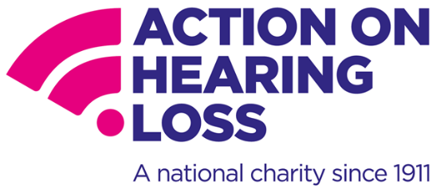

**Accessible communication – advice for GPs**

Action on Hearing Loss, formerly RNID, is the largest charity in the UK for people with deafness, hearing loss and tinnitus. The following advice is designed for GPs, as well as other healthcare professionals, when communicating with people who are deaf or have hearing loss in the context of COVID-19.

There are 12 million people in the UK with hearing loss, including an estimated 900,000 with severe or profound hearing loss. As over 70s are at higher risk of becoming severely ill due to coronavirus and **more than** **70% of people over the age of 70 have hearing loss**, it is vital that healthcare professionals are aware of the communication needs of this population.

COVID-19 also poses unique challenges for communicating with this group, as many of those with hearing loss rely on visual cues, such as lip-reading and facial expression, for communication. This **visual information is lost when someone is on a telephone or wearing a mask.** Remote consultations on the telephone, or communicating with health professionals wearing PPE, therefore, can be difficult or impossible for people who are deaf or have hearing loss.

The **Equality Act** requires reasonable adjustments to be made to support disabled people, including providing information in an accessible format. The **Accessible Information Standard** puts a legal requirement on all health and social care providers to identify communication needs and provide information in people’s preferred format. Accessible standards must be upheld, even in these unprecedented times.

Below, we set out a number of simple tips that should be adopted by GPs and incorporated within your practice:

**Ask for and meet communication needs where possible**

* Instead of using the telephone, where possible use video conferencing tools and add live captioning through video conferencing software
* Utilise [RelayUK](https://www.relayuk.bt.com/) for people with hearing loss
* Utilise Video Relay Services, such as [InterpreterNow](https://interpreternow.co.uk/), for British Sign Language users

**Where lip reading is possible:**

* Make sure there is adequate lighting
* Face the patient
* Get the patients attention before speaking
* Use normal lip movements, facial expression and gestures

**General communication tips:**

These are particularly important when the patient cannot use visual cues, such as on the telephone or when wearing PPE.

* Speak clearly – avoid shouting or speaking unnecessarily slowly
* Say things differently if people ask you to repeat or do not understand what you have said
* Check understanding by asking the patient to repeat information back – RCGP has a useful [Teach Back module](https://elearning.rcgp.org.uk/course/view.php?id=379) which utilises this for general health literacy
* Use plain language and be straight to the point
* Reduce background noise as much as possible
* Where possible, also provide written information
* If requested, speak to a relative or friend