What should we do about 2 week wait referrals for suspected cancer?
Please continue to refer for suspected cancer as usual

- If making a 2WW referral, please ensure it’s made using the latest version of the cancer referral form, contains all relevant clinical information to enable effective management and is electronically attached in e-RS RAS
- Where a patient meets the criteria for urgent referral under NG12 but the GP, in discussion with the patient, decides not to make a suspected cancer referral at this time, please ensure the patient is appropriately safety netted, monitored and can be followed up if symptoms worsen or do not resolve. Please use the Advice & Guidance option for further clinical advice
- All patients being referred should be clear about the importance of the referral
- Please ensure the practice has the correct contact telephone number on the patient record
- Please ensure all ‘pre-referral’ clinical work-up has been completed and in particular that key blood tests are completed where possible, but without delaying the referral
- Please advise patients that they may receive a telephone consultation rather than a face to face appointment with the hospital
- Please inform patients that should they develop a fever and/or new persistent cough whilst awaiting hospital appointments or tests to contact the hospital and make a different appointment at a later date, after the required period of self-isolation
- Please advise patients being referred that only one person should accompany them to the hospital clinic

Secondary Care
See diagram below for national cancer pathway for managing patients during Covid 19 within hospitals:
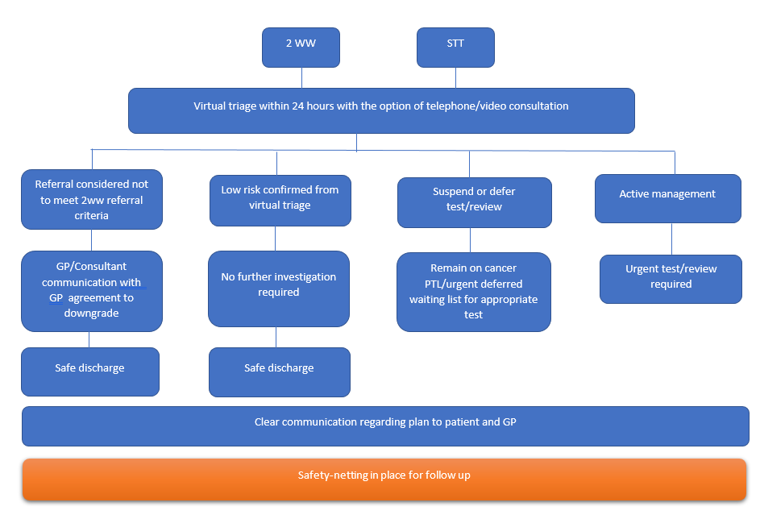

Further information below:
- GPs may, on occasion, be requested to downgrade the referral if clinical suspicion is low. The policy that a 2WW referral can only be downgraded with the referrer's consent remains
- Where a patient is referred as a suspected cancer referral and assessed virtually/by telephone, and a decision is taken not to undertake diagnostics currently due to risk to the patient, the hospital will keep the patient “suspended” on their patient tracking list (PTL) to ensure they can be appropriately followed up. Patients will be fully involved in reaching this decision and given advice on how to report worsening or new symptoms
- Where a diagnosis of cancer is confirmed, and to minimise the patient’s overall risk they are not listed for treatment immediately, the patient will remain on the PTL and a decision to treat will be recorded if the patient has agreed to treatment. Appropriate Safety Netting will be done by the hospital
- Any patient within an existing pathway wishing to defer appointments, tests or treatment due to COVID-19 related reasons, will be retained by the provider and be visible on the PTL with clear tracking comments; the hospital will ensure appropriate mechanisms are in place to ensure these patients are not ‘lost’ in the system and their pathway progressed at a later date

Sent on behalf of
Dr Louise Merriman, Cancer Clinical Lead, DDCCG
14th April 2020
Version 1.2

If you have concerns or queries, please contact:
Christine Urquhart, Head of Cancer Commissioning - christine.urquhart2@nhs.net 07770 794613
Jo Rhodes, Commissioning Manager – Cancer - jo.rhodes@nhs.net 07818 060275

