Consultations from Video Appointment Slots

- Navigate to the Appointments Ledger
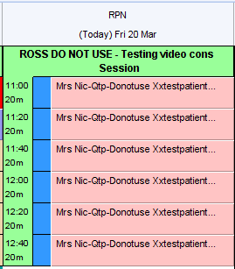

- Right Click on the appointment from which you wish to start a consultation. Note: if the patient has already entered the consultation from the Airmid app, they will show as Arrived

- Airmid Video Consultation will launch a web browser window, and create a login code. You will need to Copy and Paste into the field on the web page to access the consultation
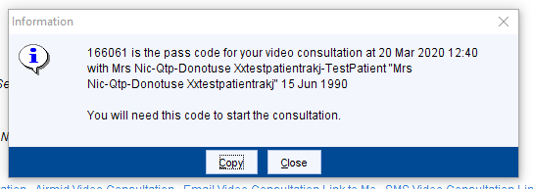

- Email Video Consultation Link to Me or SMS Video Consultation Link to Me will send a link to the email or mobile account set on your staff profile in SystmOne. Clicking on this link on another device will launch the consultation webpage.
Note: You will need the pass code that will appear on TPP after you click on the link to start the consultation
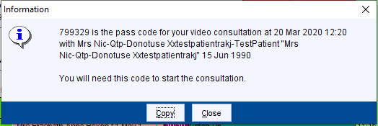

- Email Video Consultation Link to Patient will send a link to the email address recorded on the Patient Record. Note: The email address will need to be recorded before the option to email a link is selected. Note: The patient does not need access to online services or Airmid in order to use this option.

- The patient will receive an email with a hyperlink to the video consultation (this will open in their browser – Safari, Chrome and Firefox seem to work.)

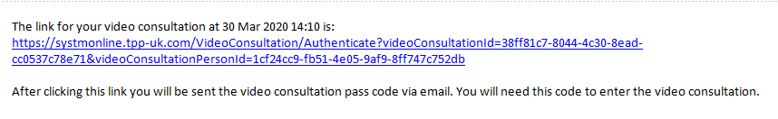

- When the patient has accessed the above link, they will receive a second email with their pass code.
