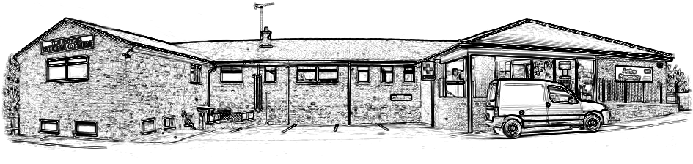

Arthur Medical Centre
Main Street, Horsley Woodhouse, Derby, DE7 6AX
Tel: 01332 880249
www.arthurmedicalcentre.co.uk

‘Delivering excellent holistic, patient-centred care through teamwork delivered by valued members of our practice team’

GP

Application Information Pack

The next few pages contain some information about the Practice which may prove useful and of interest.

Further information can be found by visiting the Practice web site at http://www.arthurmedicalcentre.co.uk

Practice Locality

Arthur Medical Centre is a semi-rural practice, located in the heart of the practice area, which extends about two and a half miles in all directions (see map on next page). Arthur Medical Centre is situated on a crossroads which divides two large villages, resulting in most of the population being close to the Practice. A few smaller scattered villages are covered, as well as the edges of three former industrial market towns, part of the borough of Amber Valley.

The current list size is around 9,100. The age-sex distribution in the practice population is broadly similar to national statistics, with a slight excess of frail, elderly patients.

The Practice serves a heterogeneous population. Some of the patients are retired ex-miners, others work for small local industry, in farming or commute to nearby cities. Denby Pottery is the largest local industry and is located on the outskirts of the practice area. There are areas of affluence in the smaller villages. There are young working families in privately owned homes. There are areas of deprivation, especially in one of the villages where there is a series of small estates. Drug misuse is generally a minor issue. The area suffers from isolation especially for those without their own transport. Apart from a few shops and post offices, there are few facilities locally. The Practice is also the principal provider of medical care for patients in two local care homes and one nursing home.

A new building development of up to 1,500 homes has been proposed for land north of Denby. This development would lie within the current practice boundary; however, this plan has not yet been fully approved/adopted by Amber Valley Borough Council. The partnership has invested in our building and over recent years bought land to extend the car park and then subsequently completed an extension and renovation of our current building. This means the practice now has 18 clinical rooms in addition to office spaces, a meeting room, two waiting rooms and two reception areas.

Teaching

All Practice staff are involved in the training of GP Registrars. We have been an accredited training practice with an excellent reputation and registrar feedback for many years. The Practice has 3 Educational/Clinical Supervisors. Following the upgrades to our building we can accommodate more trainees and currently have around 4 registrars at any one time. We also host medical students from the University of Nottingham and have previously had nursing students.

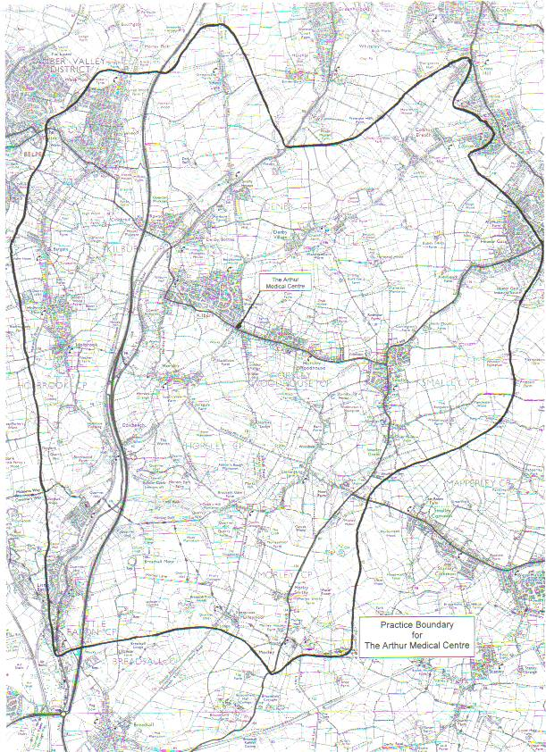
Belper
Little Eaton
Arthur Medical Centre
Heanor
Proposed
Building Development

Practice Services

Usual General Medical Services

- Nurse led chronic disease management clinics for respiratory and cardiovascular diseases, diabetes, anti-coagulation.
- Advanced Clinical Practitioner
- Clinical Pharmacist clinics for medication reviews, chronic disease management and frailty support
- Pharmacy Technician for medication updates and quality projects and prescription administration support.
- Care Coordinator organising urgent support and care for complex patients in the community.
- Social prescribers available to support patients with social issues affecting their health.
- HCA/Nurse Associate support
- First Contact Physio clinics
- Close relationships with our District Nursing & community palliative care teams
- Contraception services including IUCD fitting and implants.
- Minor operations and injections
- Child health surveillance clinics
- Weekly ward rounds for our care homes with monthly MDT meetings

Primary Care Network

Practice is part of the Belper Primary Care Network, with partner practices from Duffield and Belper. The Belper PCN consists of 4 practices with a combined list size of approximate 47,000 patients. We are proud to be part of this PCN which has nurtured a culture of collaborative working and mutual support amongst the partner practices leading to some highly successful joint ventures.

PCN Services
- Extended Access Clinics
- Menopause care
- Travel / immunisation clinics
- Smear clinics
- Health checks
- Home Visiting Service (Team Up) Chronic Pain Clinics
- Innovating with group consultations for chronic disease

LMC & GP Commissioning

The Practice actively participates within the Derbyshire Integrated Care Board and Derby and Derbyshire Local Medical Committee. One of our GP partners is a local representative on the LMC board helping us influence the strategic direction of healthcare for our area and stay abreast of relevant contract changes or opportunities.

Patient Participation Group

The practice has a well-attended and committed patient participation group. They provide regular input and patient perspective to the decisions made by the practice. They have also supported the practice on joint projects such as a patient feedback survey and updating our DNA policy. They also provide practical support such as marshalling for vaccination clinics.

The Practice has a positive, engaging approach towards CQC. One partner is the registered manager for CQC, however, each partner has several areas of responsibility which they oversee (with the aid of the relevant support team) to ensure the Practice is CQC compliant.

The Practice was last fully inspected by CQC on 3rd January 2019. Their report was very positive, with the Practice being rated as good in all services. The practice had a remote focussed inspection around the Responsive area of services in November 2023 which generated very positive, encouraging feedback regarding our efforts to manage capacity and accessibility, however our rating for this area was automatically given 'requires improvement' due to results of the previous year's patient survey. There was no change to our overall rating. The full report can be viewed on the CQC website (https://www.cqc.org.uk/location/1-575410189).

The GP Partners (number of sessions worked in brackets)

Dr Laura Wilton (4) BMedSci, BM, BS, (Nottingham 2003) MRCGP, DCH, DFFP.

Derby Vocational Training Scheme 2004-2007 and joined the Practice in April 2008. Approved Clinical Supervisor 2013.

Areas of responsibility: Managing partner; Practice nurses and Advanced Clinical Practitioner; clinical supervision; liaison with the Community Nursing team.

Interests: Contraception (including coils and implants); women’s health; paediatrics.

Dr Kate Woodier (4) BMedSci, BM, BS, (Nottingham 2007) MRCGP, DRCOG.
Derby Vocational Training Scheme 2009-2012 and joined the Practice in 2014.
Areas of responsibility: CQC Registered Manager; Clinical governance including audits and significant events; GP rotas; medical student teaching; palliative care; commissioning and development as part of the ‘Belper 4’ PCN, medical student teaching

Interests: Palliative care; women’s health; elderly medicine.

Dr Jenny Clark (5) BSc, BM, BS, (Nottingham 2011), MRCGP.
Derby Vocational Training Scheme 20013-2016 and joined the Practice in 2017.
Approved Clinical Supervisor 2019.
Areas of responsibility: Diabetes lead; Care Navigation team; HR; building matters; health and safety; joint injections and minor operations; clinical complaints

Interests: Diabetes; palliative care; training; women’s health.

Non Clinical Partner

Mr Azeem Climie MBA, Cmgr FCMI, MIHSCM
Areas of responsibility: Business Management, Human Resources, Financial and Operational Management, Facilities Management, complaints and patient liaison
Employed Staff

- Deputy Practice Manager
- QOF and Governance Lead
- Salaried GPs
- Pharmacy Technician
- Nursing Team – 4 Practice Nurses and 2 Health Care Assistants
- Care Navigation Lead
- IT and Admin Co-ordinator
- Care Navigation Team (Reception) and Administrators (13)

(Numbers of reception and admin given are numbers of staff not FTEs as most are part-time workers.)

Attached Staff (PCN, ICB, DCHS, RDH)

- Advanced Clinical Practitioners (1)
- Clinical Pharmacists
- PCN pharmacy technicians
- PCN social prescribers (2)
- PCN Home Visiting Service (Team Up)
- First Contact Physio
- Care Coordinator
- District Nursing Team

Team working at Arthur Medical Centre

Ethos

We foster a strong theme of team working, and there are excellent relationships with and within our staff. The working environment is friendly. As a partnership we are supportive, and sensitive to each other’s needs. We work hard to achieve excellent patient care by embracing evidence-based practice and innovation. All the doctors commit much time, thought and energy to the betterment of the Practice, in addition to their clinical sessions. The partners are highly motivated individuals and greatly committed to the Practice.

Working week

the Practice provides appointments on both telephone and face-to-face basis with approximately a 50/50 split for each in terms of time.

Our morning surgery starts flexibly depending on the needs of the doctor but mostly at 8:30am, followed by minimal visits, and evening surgery at 1430. Recent changes to our rota have allowed us to approach BMA guidelines on a safer number patient contacts with standard appointment length now being 15 minutes to allow for the management of more complex cases. The on-call is total triage with those patients needing a face-to-face appointment being booked on the day, and the list is capped. Urgent telephone calls are managed by the on-call doctor. Other calls are usually booked into specific telephone appointments in the morning and afternoon.

Meetings

We have weekly practice meetings on a Wednesday morning at 8:30am. This is conducted via a hybrid model of 'in-person' and utilising Microsoft Teams. We have a monthly palliative care meeting. We regularly have educational content in our weekly practice meetings including updates on NICE guidance to help our team meet their CPD requirements.

We have a daily team 'huddle' or tea break at the end of each morning surgery where the team can gather. We try to facilitate time to meet with and socialise with our colleagues within the working day; we think it is very important to take breaks and promote self-care. We regularly go for lunchtime walks in small groups around the local area which we find really beneficial as an opportunity to refresh ourselves, take a break from our desks and support one another.

There are also separate team meetings for administration, nursing, and reception staff. All of these are overseen by the Practice Business Manager and the responsible partner.

Ten meetings a year (QUEST) are supported by the ICB and we use these as an opportunity to update mandatory skills, clinical skills, training staff, and an annual away-day for the whole practice and attached staff.

Training and Education

The Practice has a long and successful track record for training GP registrars, medical students, and nurses. Delivering medical education is very much an integral philosophy of the Practice. All the GPs are involved in giving tutorials and debriefing registrars. Three partners are approved trainers (two partners are approved clinical supervisors whilst one other partner is additionally approved as an educational supervisor). We have regular medical student placements, and the nurses mentor student nurses.

In terms of developing our own knowledge, the Practice is closed to patients for team meetings at the ten QUEST meetings each year. These sessions are attended by the doctors, nurses and clinical pharmacist and include child protection reviews, CPR training, annual health and safety, information governance updates, sepsis updates. Learning needs are collated and a programme is planned to incorporate these, sometimes involving external invited speakers or attending external meetings. The administrative and reception staff either join these sessions or have their own updates at these times.

Organisation of Care

Chronic disease management is carried out as a team effort involving the Doctors, Practice and District Nurses, Advanced Clinical Practitioners, and the Clinical Pharmacists.

The Practice benefits from a team of experienced Clinical Pharmacists and pharmacy technicians (ICB and PCN employed). In additional to their roles within the Practice (including clinical updates regarding changes in guidelines and prescribing practice) they are responsible for medicines management within the Practice. They consult patients with various chronic diseases and perform medication reviews.
In additional to the Clinical Pharmacists, three of our nurse practitioners are independent prescribers. We also employ a pharmacy technician who supports our clinical pharmacists and clinical team by dealing with prescription enquires, medicine synchronisation, clinic, and discharge medication updates.

The Practice uses Ardens templates to support clinicians, to reduce the administrative burden on the clinical and administration teams and facilitate efficient long term condition management. We also use Accurx for patient communications and online consultations. We are also currently introducing the Heidi Health system.

Rota

The rota is organised in a semi-flexible manner. Some of our GPs work fixed days whereas others prefer to work their sessions flexibly across the week. The rota is generally prepared four to six weeks in advance, and requests can be made for half days etc which allows for long weekends, courses, family events to be taken without using holiday allowances. Usually, most requests can be accommodated and on the rare occasions when there is a clash, a compromise resolves the problem. In addition, an extended hours surgery is organised across the PCN with evening and weekend appointments.

Our working patterns are generally arranged more flexibly than many other surgeries; we find this allows us to meet both the needs of the individual (e.g hobbies, childcare requirements etc) and the Practice.

